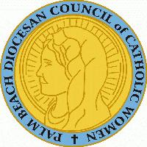

PALM BEACH DIOCESAN COUNCIL OF CATHOLIC WOMEN

***The Love of Christ Compels Us!***

The Palm Beach Diocesan Council of Catholic Women is accepting applications for its Annual High School Scholarship Award. $1,000 is awarded to a Catholic female student from each deanery, graduating from eighth grade, who will attend a Catholic high school in the Diocese of Palm Beach in the fall of 2023. The deadline to apply is April 1, 2023, and an application may be obtained by downloading from the PBDCCW website [www.pbdccw.org](http://www.pbdccw.org) – click on the High School Scholarship Application tab on the homepage. Please contact Myrna Wong at pbdccwscholarship@gmail.com for further information or questions. Scholarship winners will be invited to receive their award from Bishop Gerald M. Barbarito at the PBDCCW Annual Convention Banquet in May 2023.