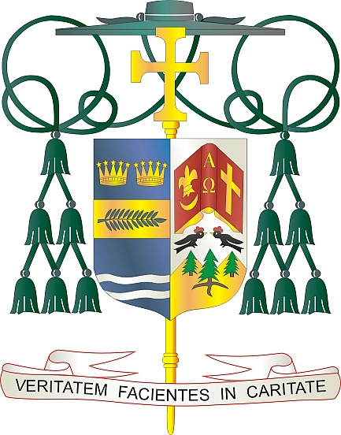
Office of
THE BISHOP

9995 North Military Trail • P.O. Box 109650
Palm Beach Gardens, Florida 33410-9650

(561) 775-9595 Fax (561) 775-7035

Diocese of Palm Beach

December 31, 2022

Dear Sisters and Brothers in Christ:

Next weekend, the parishes in the Diocese of Palm Beach will participate in a second collection to support our local Catholic schools. Within the diocese’s five counties, our 20 schools include three high schools, three preschools, two private schools, and 12 elementary schools. Thanks to the hard work of more than 550 teachers, administrators, guidance counselors and other school staff, our diocese is blessed to serve nearly 6,600 students this year. This is an increase of 15% in enrollment in the last two years, which is a true blessing to those we serve.

The Diocese of Palm Beach, Office of Catholic Schools theme this school year is Faith Inspiring Excellence. This theme reminds us that the mission of a Catholic school is to foster scholastic communities, based on the Gospel message of Jesus Christ, and rich in Catholic values and tradition. The schools have a commitment and responsibility to teach the “whole child” in mind, body, and spirit. Developing the gifts, talents and uniqueness of each student entrusted to our care, we seek to prepare leaders and Christian stewards as beacons of hope for the Catholic Church.

We invite you to join us in giving the gift of faith to a student wishing to attend a Catholic school in our diocese. Your financial contribution provides need-based scholarships at each school. Thank you very much for your faithful support, your prayers, and your gifts to help the students at our Catholic schools.

With gratitude for your continued generosity and every prayerful wish, I am

Sincerely yours in Christ,
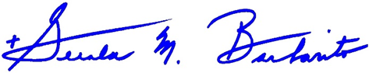

Most Reverend Gerald M. Barbarito
Bishop of Palm Beach

NOTE TO PASTORS: IT IS REQUIRED THAT YOU PUBLISH THIS LETTER IN THE PARISH BULLETIN AS A HALF PAGE OR FULL-PAGE LETTER THE WEEKEND OF DECEMBER 31/JANUARY 1, 2023. THE COLLECTION WILL TAKE PLACE JANUARY 7/8, 2023. YOU ARE WELCOME TO READ THE LETTER TO PARISHIONERS, POST THE LETTER ON SOCIAL MEDIA, AND ON YOUR WEBSITE, IN ADDITION TO HAVING IT PRINTED IN THE BULLETIN.

