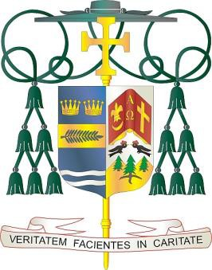Diocese of Palm Beach

9995 North Military Trail • P.O. Box 109650 Palm Beach Gardens, Florida 33410-9650

(561) 775-9595 Fax (561) 775-7035

September 2, 2023

Dear Sisters and Brothers in Christ:

Office of THE BISHOP

Next weekend, September 9and 10, the Diocese of Palm Beach will collect funds to benefit our local Catholic Charities Respect Life Ministry and three diocesan parishes with large migrant populations.

Half of the second collection will aid our local efforts to promote respect for human life through prayer, teaching, legislative action, and pastoral programs by implementing the Respect Life Program and Pastoral Plan for Pro-Life Activities of the U.S. Conference of Catholic Bishops. The ministry honors the sacredness of life by raising awareness in such areas as abortion, physician-assisted suicide/euthanasia, death penalty, end-of-life care, and bioethics.

The other part of the collection will support the parishes of St. Philip Benizi in Belle Glade, St. Mary in Pahokee, and Holy Cross in Indiantown. Your support assists the parishes greatly in ministering to their diverse pastoral and social needs. Your prayerful and compassionate response to this collection will help change the lives of those who cry out to God in need as they seek a safe home for their hard-working families.

With gratitude for your continued generosity and with every prayerful wish, I am

Sincerely yours in Christ,

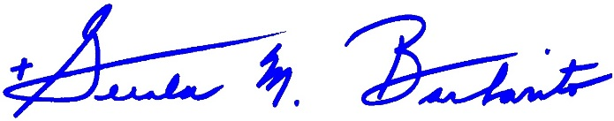

Most Reverend Gerald M. Barbarito Bishop of Palm Beach

**NOTE TO PASTORS: IT IS REQUIRED THAT YOU PUBLISH THIS LETTER IN THE PARISH BULLETIN AS A HALF PAGE OR FULL-PAGE LETTER THE WEEKEND OF SEPTEMBER 2/3, 2023. THE COLLECTION WILL TAKE PLACE SEPTEMBER 9/10, 2023. YOU ARE WELCOME TO READ THE LETTER TO PARISHIONERS, POST THIS LETTER ON SOCIAL MEDIA, AND ON YOUR WEBSITE IN ADDITION TO HAVING IT PRINTED IN THE BULLETIN.**