[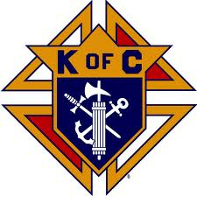](http://www.google.com/imgres?imgurl=http://www.6292.kofc.com/resources/kofc_clipart/logos/eomed.jpg&imgrefurl=http://www.6292.kofc.com/resources/kofc_clipart/logos/ceomed.htm&h=737&w=737&sz=150&tbnid=Xr3WHwIt9gN9jM:&tbnh=85&tbnw=85&zoom=1&usg=__HK5qik7fGAvPMjyzbhTlh9CqbD4=&docid=SzRYS4Eo0zVAYM&sa=X&ei=JETIUb3zCI3S9AS5ioH4Ag&sqi=2&ved=0CEYQ9QEwAg&dur=722) 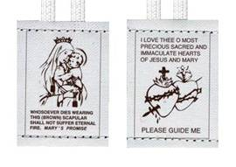 **[](http://www.google.com/imgres?imgurl=http://www.6292.kofc.com/resources/kofc_clipart/logos/eomed.jpg&imgrefurl=http://www.6292.kofc.com/resources/kofc_clipart/logos/ceomed.htm&h=737&w=737&sz=150&tbnid=Xr3WHwIt9gN9jM:&tbnh=85&tbnw=85&zoom=1&usg=__HK5qik7fGAvPMjyzbhTlh9CqbD4=&docid=SzRYS4Eo0zVAYM&sa=X&ei=JETIUb3zCI3S9AS5ioH4Ag&sqi=2&ved=0CEYQ9QEwAg&dur=722)**

**INVESTITURE TO THE “SABBATINE PRIVILEGE” OF THE**

**CONFRATERNITY OF OUR LADY OF MOUNT CARMEL THROUGH THE BROWN SCAPULAR**

**ON THE FEAST OF OUR LADY OF LOURDES**

**FRIDAY, FEBRUARY 11, 2022 – 6:00 P.M. SHARP**

**THE CATHEDRAL OF ST. IGNATIUS LOYOLA - PALM BEACH GARDENS**

**You are invited to participate in this very Spiritual Devotion to Our Blessed Mother on the Feast Day of Our Lady of Lourdes. Spouses, families, friends & those who have been wearing a Brown Scapular but have not been invested are invited. Existing Members of the Confraternity are asked to join us in welcoming our new members.**

**REGISTRATION IS REQUIRED – SEATING IS LIMITED**

**There is no cost to participate.**

**Free-will donations are appreciated.**

**CONTACT: COSTANTE SALVADOR –** [**costante.salvador@outlook.com**](mailto:costante.salvador@outlook.com) **– (561) 762-5415**