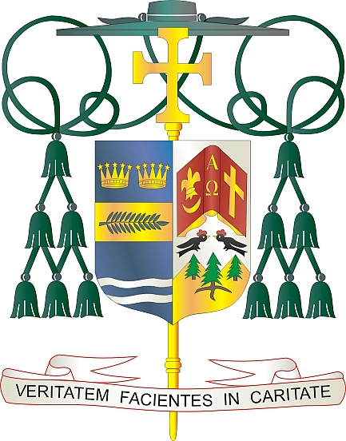
Office of
THE BISHOP

9995 North Military Trail • P.O. Box 109650
Palm Beach Gardens, Florida 33410-9650

(561) 775-9595 Fax (561) 775-7035

Diocese of Palm Beach

April 16, 2022

Dear Brothers and Sisters in Christ:

Next weekend, April 23 and 24, 2022, our diocese will participate in the annual Peter’s Pence Collection. Donations made to this collection can be directed by the Pope in financing the many activities and services carried out by the Curia (formation of the clergy, communication, promotion of integral human development, education, justice, etc.) and in contributing to numerous works of material assistance for the most in need.

Funds from the Peter’s Pence collection allows the Holy Father to respond quickly when natural disasters and tragedies occur around the world. The Office of Papal Charities has recently used proceeds from Peter’s Pence to provide food and medical supplies for the people of the Ukraine, for those seeking refuge in neighboring countries, and for victims of natural disasters in Croatia, Haiti, the Philippines, Albania, South Sudan, and Greece. Together, with our Holy Father, we can reach out to those most in need.

By contributing to Peter’s Pence, we can together support the Pope’s mission through the activities of the Holy See and the initiatives of solidarity in favor of the most vulnerable, to whom the Church’s attention has been traditionally directed.

With gratitude for your continued generosity and every prayerful wish, I am

Sincerely yours in Christ,
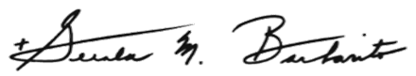

Most Reverend Gerald M. Barbarito
Bishop of Palm Beach

NOTE TO PASTORS: IT IS REQUIRED THAT YOU PUBLISH THIS LETTER IN THE PARISH BULLETIN AS A HALF-PAGE OR FULL-PAGE LETTER THE WEEKEND OF APRIL 16/17, 2022. THE COLLECTION WILL TAKE PLACE APRIL 23/24, 2022. YOU ARE WELCOME TO READ THE LETTER TO PARISHIONERS, POST THIS LETTER ON SOCIAL MEDIA AND ON YOUR WEBSITE, IN ADDITION TO HAVING IT PRINTED IN THE BULLETIN.

