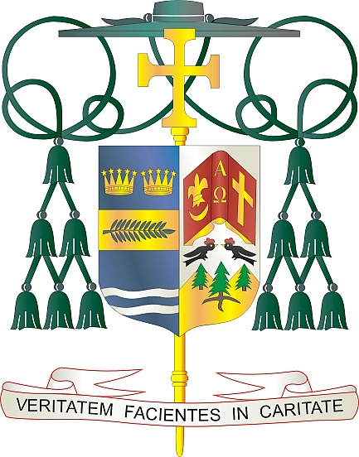
Office of
THE BISHOP

9995 North Military Trail • P.O. Box 109650
Palm Beach Gardens, Florida 33410-9650

(561) 775-9595 Fax (561) 775-7035

Diocese of Palm Beach

November 6, 2021

Dear Sisters and Brothers in Christ:

Next weekend our diocese will have a second collection for the Catholic Campaign for Human Development (CCHD). The CCHD seeks to promote Catholic social teachings and the dignity of men and women who give glory to God through the gift of human labor. Through various programs, initiatives, and organizations, the CCHD seeks to uphold the dignity of the American worker and all they do for this great nation.

Twenty-five percent of the donations collected next weekend stays in our diocese and directly benefits our local Catholic Charities initiatives to support those in need. Catholic Charities of the Diocese of Palm Beach serves more than 12,500 clients through 11 programs and ministries within our five counties. Currently, 38 million people in the United States live in poverty. This collection funds programs that empower communities to address the challenges they face in supporting those living with poverty across the country.

Your spiritual and financial support of the CCHD is an act of solidarity with our brothers and sisters in need. May God bless you with every grace and peace, and may our Blessed Mother always intercede for you.

With gratitude for your continued generosity and every prayerful wish, I am

Sincerely yours in Christ,
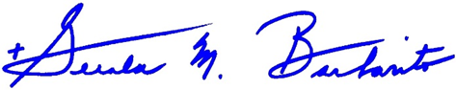

Most Reverend Gerald M. Barbarito
Bishop of Palm Beach

NOTE TO PASTORS: IT IS REQUIRED THAT YOU PUBLISH THIS LETTER IN THE PARISH BULLETIN AS A HALF PAGE OR FULL-PAGE LETTER THE WEEKEND OF NOVEMBER 6/7, 2021. THE COLLECTION WILL TAKE PLACE NOVEMBER 13/14, 2021. YOU ARE WELCOME TO READ THE LETTER TO PARISHIONERS, POST THIS LETTER ON SOCIAL MEDIA, AND ON YOUR WEBSITE IN ADDITION TO HAVING IT PRINTED IN THE BULLETIN.

