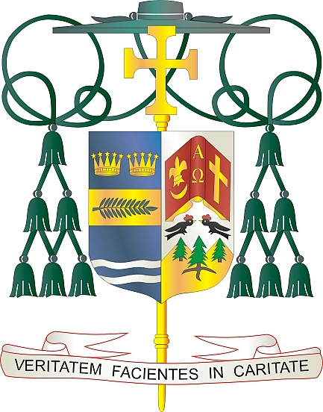

Office of  
THE BISHOP

9995 North Military Trail • P.O. Box 109650

Palm Beach Gardens, Florida 33410-9650

(561) 775-9595 Fax (561) 775-7035

## Diocese of Palm Beach

May 9, 2025

Dear Sisters and Brothers in Christ:

Next weekend, during this *Jubilee Year of Hope,* a special collection will be taken up to help spread the Gospel message throughout our Diocese of Palm Beach, nation, and world.

Twenty-five percent of the funds collected will support the national United States Conference of Catholic Bishop’s Catholic Communication Campaign to bolster national communication efforts. While, twenty-five percent of the collection will support our local diocesan projects, such as the weekly Televised Catholic Mass, *Florida Catholic* e-edition, our active social media presence and website ([www.DiocesePB.org](http://www.DiocesePB.org)). These media tools help the Church inform, instruct, and inspire the faithful near and far.

As Pope Francis said in the 59th World Communications Day message for 2025: “I encourage you to discover and make known the many stories of goodness hidden in the folds of the news, imitating those gold-prospectors who tirelessly sift the sand in search of a tiny nugget. It is good to seek out such seeds of hope and make them known. It helps our world to be a little less deaf to the cry of the poor, a little less indifferent, a little less closed in on itself. May you always find those glimmers of goodness that inspire us to hope.”

The other fifty percent of the funds collected will support the Catholic University of America, a national research university in Washington, D.C. By donating to CUA, you aid the more than 5,700 students who are future Catholic leaders being formed by an exceptional, faith-rooted education.

With gratitude for your continued generosity and every prayerful wish, I am

Sincerely yours in Christ,

Most Reverend Gerald M. Barbarito  
 Bishop of Palm Beach

**NOTE TO PASTORS: IT IS REQUIRED THAT YOU PUBLISH THIS LETTER IN THE PARISH BULLETIN AS A HALF-PAGE OR FULL-PAGE LETTER THE WEEKEND OF MAY 10/11, 2025. THE COLLECTION WILL TAKE PLACE MAY 17/18, 2025. YOU ARE WELCOME TO READ THE LETTER TO PARISHIONERS, POST THE LETTER ON SOCIAL MEDIA, AND ON YOUR WEBSITE, IN ADDITION TO HAVING IT PRINTED IN THE BULLETIN.**