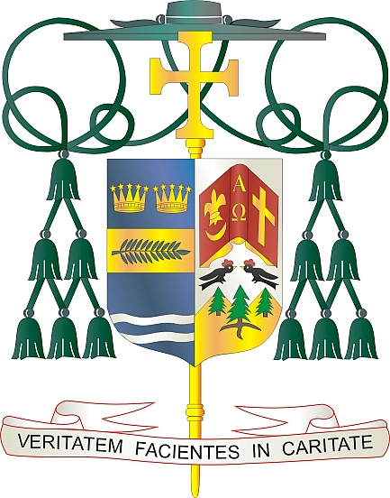
Office of
THE BISHOP

9995 North Military Trail • P.O. Box 109650
Palm Beach Gardens, Florida 33410-9650

(561) 775-9595 Fax (561) 775-7035

Diocese of Palm Beach

July 2022

Dear Brothers and Sisters in Christ,

God’s plan for human love and sexuality is good news and calls married couples to live with Christ-like love in sacramental marriage. While this call to authentic love is free, total, faithful and fruitful, the desire and need to manage human fertility remains part of the human experience. In response, the Church proposes Natural Family Planning (NFP) as a modern, scientific method available to couples for planning their families by enabling them to participate in God’s creative action without breaking the inseparable link between the unitive and procreative meanings of the conjugal (marital) act. As NFP becomes a way of life, the couple cooperates with each other and God in responsibly planning their family without the devastating spiritual and physical harm caused by artificial contraceptive methods.

Each year, the United States Conference of Catholic Bishops (USCCB) sponsors a national educational campaign called Natural Family Planning Awareness week, to highlight the good news about God’s perfect plan for human love and sexuality. This year, Natural Family Planning (NFP) Awareness week will be observed from July 24 through July 30 with the theme: Called to the Joy of Love, Natural Family Planning, Supporting God’s gifts of love and life in marriage.

During this week, we also observe the anniversary of Pope Paul VI’s papal encyclical Humanae Vitae (July 25) that articulates Catholic beliefs about human sexuality, conjugal love, and responsible parenthood. This week also marks the feast of Saints Joachim and Anne (July 26), the parents of the Blessed Mother and grandparents of her Son Jesus. Pope Francis has also designated that feast as World Grandparents’ Day, a fitting commemoration during National NFP Awareness Week to highlight the importance of family and the wonderful blessing of children in our lives.

I would like to take this opportunity to congratulate those married couples who live out their marriage commitment to free, total, faithful and fruitful love. I encourage all married couples and those preparing for marriage to reflect on their current or future marriages and how they can authentically and responsibly fulfill their commitment to fruitful love. If you have not yet considered NFP or have questions, I encourage you to investigate and discover the richness of NFP. Please visit our website at www.diocesepb.org/naturalfamilyplanning for resources and additional information or call 561-775-9557.

With every prayerful wish, I am

Sincerely yours in Christ,
Most Reverend Gerald M. Barbarito
Bishop of Palm Beach

