
October 2, 2026

Dear Sisters and Brothers in Christ:

Next weekend, October 10/11, the faithful of our diocese are asked to participate in a second collection for World Mission Sunday, observed October 18, which honors those who follow the Gospel mandate to go out and preach to all nations. The 2026 World Mission Sunday theme, chosen by Pope Leo XIV, is “One in Christ, United in Mission,” highlighting the unity of believers, founded on the union of Christ with the Father, and the consequent common mission of evangelization.

The annual collection supports more than 1,000 Catholic communities in Asia, Africa, the Pacific Islands, and parts of Latin America and Europe. By supporting this collection, we join with many others to assist these missions and ministries and provide help for some of the most vulnerable regions around the world. This year’s worldwide celebration of World Mission Sunday will mark the 100th anniversary of the day’s establishment by Pope Pius XI at the suggestion of the Pontifical Society for the Propagation of the Faith.

Pope Leo, recalling his personal experience as a priest and later as a missionary bishop in Peru, said: “I saw first-hand how the faith, the prayer, and the generosity shown on World Mission Sunday can transform entire communities.” Please consider generously supporting this worthwhile collection to spread the message of Jesus throughout the world.

Assuring you and all those you love of my continued remembrance in the celebration of the Holy Eucharist, and commending you to the loving intercession of the Blessed Virgin Mary, Queen of the Apostles, I remain

Sincerely yours in our Lord Jesus Christ,
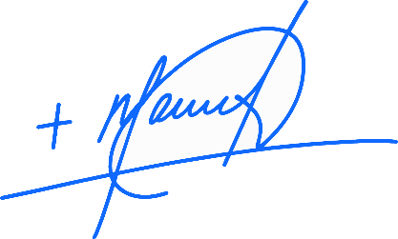
Most Reverend Manuel de Jesús Rodríguez, J.C.D.
Bishop of Palm Beach

NOTE TO PASTORS: IT IS REQUIRED THAT YOU PUBLISH THIS LETTER IN THE PARISH BULLETIN AS A HALF-PAGE OR FULL-PAGE LETTER THE WEEKEND OF OCTOBER 3/4. THE COLLECTION WILL TAKE PLACE OCTOBER 10/11, 2026. YOU ARE WELCOME TO READ THE LETTER TO PARISHIONERS, POST THIS LETTER ON SOCIAL MEDIA, AND ON YOUR WEBSITE IN ADDITION TO HAVING IT PRINTED IN THE BULLETIN.

