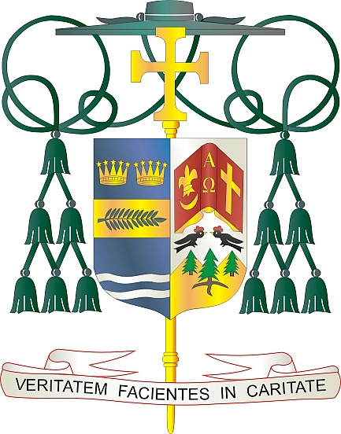
Office of
THE BISHOP

9995 North Military Trail • P.O. Box 109650
Palm Beach Gardens, Florida 33410-9650

(561) 775-9595 Fax (561) 775-7035

Diocese of Palm Beach

June 3, 2023

Dear Sisters and Brothers in Christ:

Next weekend, June 10/11, the Diocese of Palm Beach will have a special collection for two worthy causes: Black and Indian Missions and the Catholic Home Missions.

The Black and Indian Mission collection, established as the first national collection in 1874, has proven itself to be a successful vehicle for sharing the resources of the Church’s members to provide for the needs of our African American, Native American and Alaska Native brothers and sisters. Your support helps ensure the presence of missionaries, places Bibles and catechetical materials in the hands of priests, lay leaders and consecrated men and women, and impacts pastoral work across the country.

The Catholic Home Missions portion of the collection provides home mission dioceses in every region of the United States and its territories with the resources to welcome and minister to their growing multicultural populations. Your support of this appeal makes a difference in Catholic mission communities through initiatives for evangelization, faith formation, human life and dignity, strengthening marriages and families, and priestly and religious vocations.

With gratitude for your continued generosity and every prayerful wish, I am

Sincerely yours in Christ,
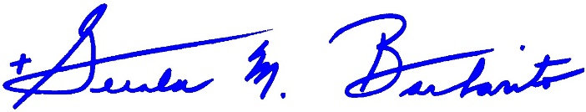
Most Reverend Gerald M. Barbarito
Bishop of Palm Beach

NOTE TO PASTORS: IT IS REQUIRED THAT YOU PUBLISH THIS LETTER IN THE PARISH BULLETIN AS A HALF-PAGE OR FULL-PAGE LETTER THE WEEKEND OF JUNE 3/4, 2023. THE COLLECTION WILL TAKE PLACE JUNE 10/11, 2023. YOU ARE WELCOME TO READ THE LETTER TO PARISHIONERS, POST IT ON SOCIAL MEDIA AND ON YOUR WEBSITE, IN ADDITION TO HAVING IT PRINTED IN THE BULLETIN.

