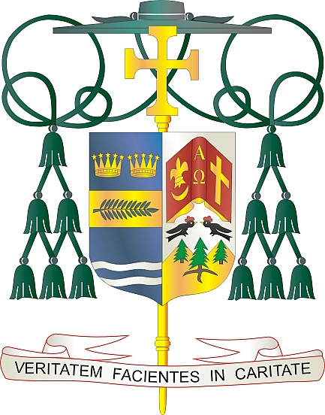
Office of
THE BISHOP

9995 North Military Trail • P.O. Box 109650
Palm Beach Gardens, Florida 33410-9650

(561) 775-9595 Fax (561) 775-7035

Diocese of Palm Beach

April 2, 2021

Dear Sisters and Brothers in Christ:

Every year on Good Friday, a second collection—called The Pontifical Good Friday Collection—is taken in Catholic Churches throughout the world to support the work of the Franciscans working in the Holy Land. Pope Francis has asked parishes to participate in this collection, which supports Church minister in parishes, funds Catholic schools and offers religious education. The Pontifical Good Friday Collection also helps to preserve the sacred shrines and, in times of crisis, provide humanitarian aid to refugees.

Last year’s Pontifical Good Friday Collection supported numerous parishes and academic institutions, supported a home for children impacted by domestic violence, funded scholarships for high school and university education, offered financial assistance at senior care facilities in Bethlehem and Nazareth, preserved 65 shrines connected with the life of Jesus and the prophets and much more.

It has never been easy to be a Christian in the Holy Land. In these challenging times in the Middle East, Christians are experiencing unique hardships. We have an opportunity to help them through the Pontifical Good Friday Collection. With your help, the Franciscans can continue to be a light of hope to those living in Holy Land.

Thank you for supporting this collection. When you contribute to the Pontifical Good Friday Collection, you become an instrument of peace in a troubled land.

With gratitude for your continued generosity and every prayerful wish, I am

Sincerely yours in Christ,
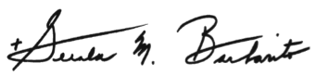

Most Reverend Gerald M. Barbarito
Bishop of Palm Beach

NOTE TO PASTORS: IT IS REQUIRED THAT YOU PUBLISH THIS LETTER IN THE PARISH BULLETIN AS A HALF PAGE OR FULL-PAGE LETTER THE WEEKEND OF MARCH 27/28, 2021. THE COLLECTION WILL TAKE PLACE APRIL 2, 2021. YOU ARE WELCOME TO READ THE LETTER TO PARISHIONERS, POST THIS LETTER ON SOCIAL MEDIA, AND ON YOUR WEBSITE IN ADDITION TO HAVING IT PRINTED IN THE BULLETIN.

