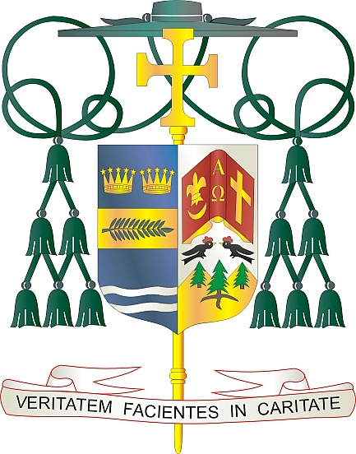
Office of
THE BISHOP

9995 North Military Trail • P.O. Box 109650
Palm Beach Gardens, Florida 33410-9650

(561) 775-9595 Fax (561) 775-7035

Diocese of Palm Beach

June 4, 2022

Dear Sisters and Brothers in Christ:

Next weekend, June 11/12, the Diocese of Palm Beach will have a special collection for two causes: Black and Indian Missions and the Catholic Home Missions.

The Black and Indian Mission collection supports three distinct but inter-related organizations (Bureau of Catholic Indian Missions, Commission for the Catholic Missions and Catholic Negro-American Mission Board), each with its own purpose and history, but all seeking to fulfill the one cause. Founded by the Catholic bishops of the United States, each organization cooperates with local diocesan communities to spread the Good News of Jesus Christ and respond to real and pressing needs on the ground.

The Catholic Home Missions portion of the collection is an annual appeal through the U.S. Conference of Catholic Bishops that supports dioceses and eparchies in the United States and its territories that are unable to sustain basic ministries without outside financial help. The funds support initiatives for evangelization, faith formation, human life and dignity, strengthening marriages and families, priestly and religious vocations, ministries to Hispanic, Native American and Alaskan Indigenous populations, and assistance to dioceses and parishes with administrative needs, such as communications and pastoral planning.

With gratitude for your continued generosity and every prayerful wish, I am

Sincerely yours in Christ,
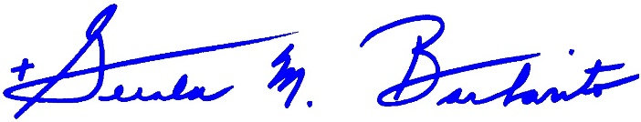
Most Reverend Gerald M. Barbarito
Bishop of Palm Beach

NOTE TO PASTORS: IT IS REQUIRED THAT YOU PUBLISH THIS LETTER IN THE PARISH BULLETIN AS A HALF-PAGE OR FULL-PAGE LETTER THE WEEKEND OF JUNE 4/5, 2022. THE COLLECTION WILL TAKE PLACE JUNE 11/12, 2022. YOU ARE WELCOME TO READ THE LETTER TO PARISHIONERS, POST IT ON SOCIAL MEDIA AND ON YOUR WEBSITE, IN ADDITION TO HAVING IT PRINTED IN THE BULLETIN.

