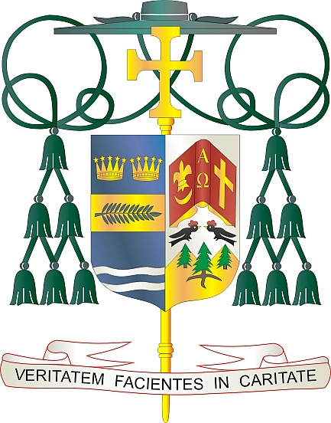
Office of
THE BISHOP

9995 North Military Trail • P.O. Box 109650
Palm Beach Gardens, Florida 33410-9650

(561) 775-9595 Fax (561) 775-7035

Diocese of Palm Beach

January 1, 2022

Dear Sisters and Brothers in Christ:

Next weekend, the parishes in the Diocese of Palm Beach will participate in a second collection to support our local Catholic schools. Due to the pandemic, we did not hold this second collection last year, so your participation this year is greatly appreciated.

Our 20 Catholic schools span our five counties, including three high schools, three preschools, two private schools, and twelve elementary schools. Thanks to the hard work of more than 550 teachers, administrators, guidance counselors, and school staff, our diocese is able to serve more than 6,400 school students this year.

The Diocese of Palm Beach, Office of Catholic Schools theme this school year is: Faith Inspiring Excellence. This theme reminds us that the mission of a Catholic school is to foster scholastic communities, based on the Gospel message of Jesus Christ, and rich in Catholic values and tradition. The schools have a commitment and responsibility to teach the “whole child” in mind, body, and spirit. Developing the gifts, talents and uniqueness of the students entrusted to our care, we seek to prepare leaders and Christian stewards as beacons of hope for the Catholic Church.

We invite you to join us in giving the gift of faith to a student wishing to attend a Catholic school in our diocese. Your financial contribution provides need-based scholarships at each school. Thank you very much for your faithful support, your prayers, and your gifts to help the students at our Catholic schools in the Diocese of Palm Beach.

With gratitude for your continued generosity and every prayerful wish, I am

Sincerely yours in Christ,
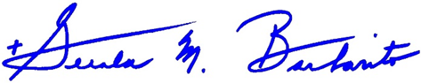

Most Reverend Gerald M. Barbarito
Bishop of Palm Beach

NOTE TO PASTORS: IT IS REQUIRED THAT YOU PUBLISH THIS LETTER IN THE PARISH BULLETIN AS A HALF PAGE OR FULL-PAGE LETTER THE WEEKEND OF JANUARY 1/2, 2022. THE COLLECTION WILL TAKE PLACE JANUARY 8/9, 2022. YOU ARE WELCOME TO READ THE LETTER TO PARISHIONERS, POST THE LETTER ON SOCIAL MEDIA, AND ON YOUR WEBSITE, IN ADDITION TO HAVING IT PRINTED IN THE BULLETIN.

