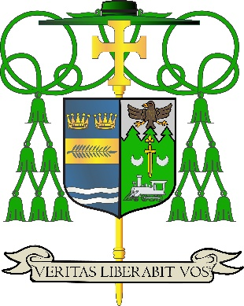

Office of
THE DIOCESAN
BISHOP

9995 North Military Trail • P.O. Box 109650
Palm Beach Gardens, Florida 33410-9650

(561) 775-9595 Fax (561) 775-7035

Diocese of Palm Beach

March 27, 2026

Dear Brothers and Sisters in Christ:

Every year, the Holy Father asks parishioners to support the Pontifical Good Friday collection, which seeks to bolster Christian presence in the Holy Land, aid ministry in its sacred shrines and parishes, provide for formation and education in communities and schools, and fund basic needs for struggling people. The 2026 collection will be taken up on Good Friday, April 3.

Your awareness of and generosity toward this year’s collection will help enable Christians and the Catholic Church to stay in the Holy Land, in the very land made holy by the life, death and Resurrection of Jesus. The Franciscans of the Custody of the Holy Land help maintain and safeguard sacred sites and shrines, as well as care for the “living stones” who are present among them.

I humbly ask for your prayers and financial support for this annual collection, as encouraged by Pope Leo XIV. By supporting these efforts, you stand with the Church in the Holy Land, and you become an instrument of peace in a troubled region.

Assuring you and all those you love of my continued remembrance in the celebration of the Holy Eucharist, and commending you to the loving intercession of the Blessed Virgin Mary, Queen of the Apostles, I remain

Sincerely yours in our Lord Jesus Christ,
Most Reverend Manuel de Jesús Rodríguez, J.C.D.
Bishop of Palm Beach

NOTE TO PASTORS: IT IS REQUIRED THAT YOU PUBLISH THIS LETTER IN THE PARISH BULLETIN AS A HALF-PAGE OR FULL-PAGE LETTER THE WEEKEND OF MARCH 28/29, 2026. THE COLLECTION WILL TAKE PLACE APRIL 3, 2026. YOU ARE WELCOME TO READ THE LETTER TO PARISHIONERS, POST THIS LETTER ON SOCIAL MEDIA, AND ON YOUR WEBSITE, IN ADDITION TO HAVING IT PRINTED IN THE BULLETIN.

