Diocesan Services Appeal 2022
April Bulletin and/or Ambo Announcements

Option #1:
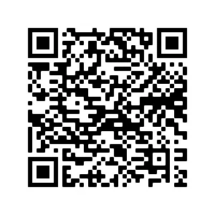
During the month of April, we continue to raise funds to reach our parish goal for the DSA, and, in a special way, we thank those who have already given so generously. As of now, our parish has reached *** percent of its goal and encourage those who have not participated to make a gift at this time. By scanning this QR code, you can make an online pledge or gift using a secure website. Thank you again for being a blessing to our parish.

Option #2:
The funding received from DSA donations supports the formation, resources, housing and expenses of seminarians, who will then bless the parishes in the Diocese of Palm Beach. By supporting these men, future sacramental ministry will be ensured. The formation of permanent deacons, through study, prayer, and human and pastoral preparation, is also supported by the DSA. Visit https://donate.diocesepb.org/ to make your gift today!

Option #3:
“The church needs priests, the Diocese of Palm Beach needs priests. And I have always wanted to serve the people of God. And I have been serving the people of God actually for most of my life, but I’ve always wanted to do it as a priest. I had to give up everything. And the people of God in the Diocese of Palm Beach have been so generous and so loving in helping us do what we do. I can’t thank them enough.”— Deacon Daniel Donohue
Visit https://donate.diocesepb.org/ to make your gift to the DSA today and support the vocations programs in our diocese.

