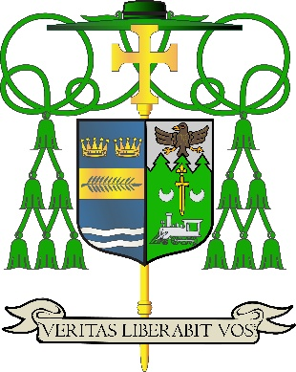

Office of
THE DIOCESAN BISHOP

9995 North Military Trail • P.O. Box 109650
Palm Beach Gardens, Florida 33410-9650

(561) 775-9595 Fax (561) 775-7035

Diocese of Palm Beach
March 3, 2026

Special Message from Most Reverend Manuel de Jesús Rodríguez on Prayer and Dialogue for Peace

- “In light of the escalating U.S.-Iran military actions, let us join Pope Leo in praying that world leaders return to dialogue and pursue every path toward just and lasting peace. We also pray for the safety of our U.S. troops and mourn all who have fallen.”

- Bishop Manuel de Jesús Rodríguez

- “A la luz de las crecientes acciones militares entre Estados Unidos e Irán, unámonos al Papa León en la oración para que los líderes mundiales regresen al diálogo y busquen todo camino hacia una paz justa y duradera. También oramos por la seguridad de nuestras tropas de EE. UU. y lamentamos a todos los que han caído.”

- Monseñor Manuel de Jesús Rodríguez

- “Nan limyè aksyon militè Etazini ak Iran ki vini agrave, an nou mete tèt ansanm ak Pap Leon pou priye pou lidè mondyal yo retounen nan dyalòg epi pouswiv tout chemen ki mennen nan yon lapè jis ak dirab. Nou priye tou pou sekirite twoup ameriken nou yo epi tou nou nan lapenn pou tout moun ki tonbe yo.”

- Evèk Manuel de Jesús Rodríguez

To view the excerpt from Pope Leo XIV calling for prayer and diplomacy, please click here. To read the statement from Archbishop Coakley, president of the U.S. Conference of Catholic Bishops, please click here.

We implore our Blessed Mother, Mary, Queen of Peace, to intercede and pray for our restless world and for a lasting peace: “O Virgin Mary, Queen of peace, you who stood at the foot of the cross, obtain from your Son pardon for our sins; you who never doubted the victory of his resurrection, sustain our faith and our hope; you who are enthroned as Queen in glory, teach us the royal road of service and the glory of love. Amen.” ~ Pope Francis, Prayer for Peace

###

