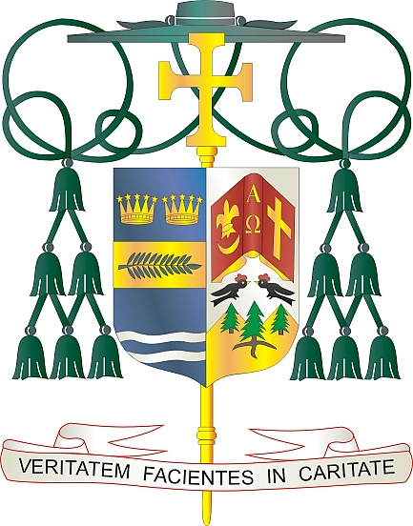
Office of
THE BISHOP

9995 North Military Trail • P.O. Box 109650
Palm Beach Gardens, Florida 33410-9650

(561) 775-9595 Fax (561) 775-7035

Diocese of Palm Beach

March 5, 2022

Dear Sisters and Brothers in Christ:

Next weekend, March 12-13, is the annual Diocese of Palm Beach collection for the education of seminarians and the formation of priests. The priestly discernment and seminary formation process is important, and these seminarians need our spiritual and financial support. The funds raised in this collection are used to support the cost of tuition, housing, education, and pastoral training of our seminarians. For example, the cost of tuition for one seminarian per year is $22,000, and the room and board for one seminarian is $12,100 per year.

Currently, there are eight seminarians from our Diocese who are dedicating themselves to this important process of understanding their vocation. With God’s grace, we will have three ordinations this year: two priestly ordinations (Rev. Mr. Daniel Donohue and Rev. Mr. Armando Leon) and one diaconate ordination (Mr. Marc Gustinelli).

By your generosity, our seminarians can devote themselves fully to the task of priestly formation, without having to worry about the financial burden of seminary. With them, you walk the journey of faith and ensure that the sacraments will continue to nourish the faithful for generations to come.

St. Paul says in the Scriptures, “This service that you perform is not only supplying the needs of the Lord’s people but is also overflowing in many expressions of thanks to God” (2 Cor 9:12). I thank you for your prayers for an increase in vocations and for these men and assure you those prayers are working.

With gratitude for your continued generosity and every prayerful wish, I am

Sincerely yours in Christ,
Most Reverend Gerald M. Barbarito
Bishop of Palm Beach

