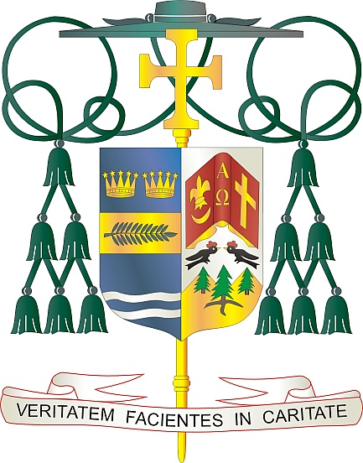
Office of
THE BISHOP

9995 North Military Trail • P.O. Box 109650
Palm Beach Gardens, Florida 33410-9650

(561) 775-9595 Fax (561) 775-7035

Diocese of Palm Beach

February 6, 2026

Dear Sisters and Brothers in Christ:

All parishes in our Diocese will collect funds next weekend, February 14/15, to support our local priests living in retirement, many of whom continue to serve the Church in a wide range of ministries. These priests, who have faithfully served in the Diocese of Palm Beach for decades, are greatly helped by the money donated in this special collection.

Your generous support of our retired priests, through your prayers and financial assistance, is necessary to allow them to continue their work, make a positive impact on the faithful, and lead healthy, purposeful lives in retirement. Please ask God to bless them as you show appreciation for their years of dedicated, life-giving service.

With gratitude for your continued generosity and every prayerful wish, I am

Sincerely yours in Christ,
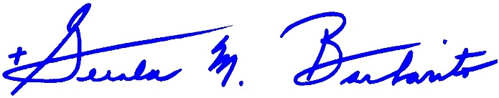
Most Reverend Gerald M. Barbarito
Bishop Emeritus
Apostolic Administrator

NOTE TO PASTORS: IT IS REQUIRED THAT YOU PUBLISH THIS LETTER IN THE PARISH BULLETIN AS A HALF-PAGE OR FULL-PAGE LETTER THE WEEKEND OF FEBRUARY 7/8, 2026. THE COLLECTION WILL TAKE PLACE FEBRUARY 14/15, 2026. YOU ARE WELCOME TO READ THE LETTER TO PARISHIONERS, POST THIS LETTER ON SOCIAL MEDIA, AND ON YOUR WEBSITE IN ADDITION TO HAVING IT PRINTED IN THE BULLETIN.

