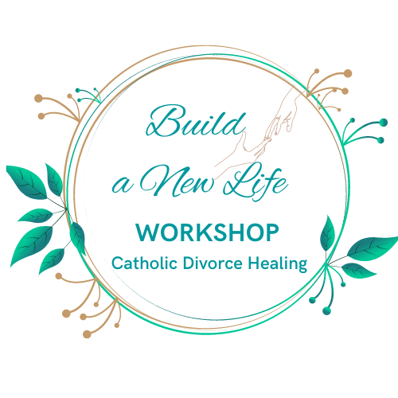
Build a New Life Workshop
A 12-Week Online Healing & Support Intensive Workshop for Separated and Divorced Catholics

What Is It?
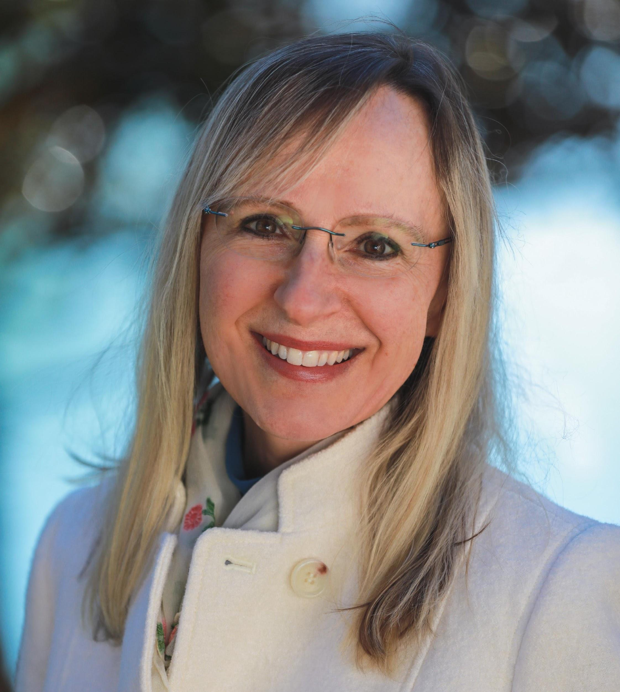
Build a New Life is a Christ-centered, virtual support and healing Intensive created especially for Catholics experiencing the pain of marital stress, separation, divorce, or annulment.
Led by certified Catholic Divorce Healing Coach Carolyn Klika, this 12-week journey provides tools for emotional healing, spiritual renewal, and practical rebuilding—grounded in the truth and love of the Church.

What You’ll Receive:
✅ 12 Live weekly sessions via Zoom (with replays available)
✅ A supportive faith-based community
✅ Step-by-step guidance to help you regain peace, confidence, and clarity
✅ Tools to navigate co-parenting, annulments, grief, identity, and more
✅ A printed workbook for reflection and transformation plus 1 year access to videos

When Does It Start?
🗓️ Wednesdays, Starting September 11 🕖 7:00 PM Eastern Time (90 minutes on Zoom)
Join from anywhere | You're not alone | Limited seats | Scholarships available

Hear from Past Participants:
“This workshop was a lifeline. I finally felt seen, supported, and spiritually grounded again.”
“If I hadn’t said yes, I’d still be stuck in bitterness and fear.”
“I got my connection back with God and my Faith. I didn’t think this growth could happen!”
“I immediately found my tribe in BNLW…people who really understood and supported me.”
Significant Proven Healing: On average, participants reported a dramatic drop in emotional pain—from 8 out of 10 before the program to just 3 out of 10 afterward.

How to Join:
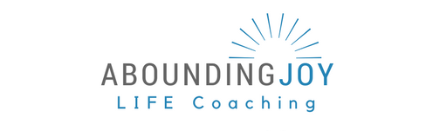
🌐 Register or Learn More: AboundingJoyMinistry.com/events
📧 Questions? Contact Carolyn Klika: carolyn@aboundingjoyministry.com
Hopeful. Healing. Faithful. Transformative.
Presented by Abounding Joy Ministry

