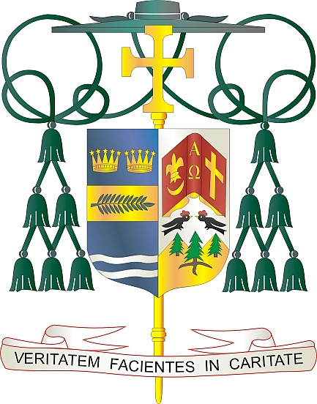

Office of  
THE BISHOP

9995 North Military Trail • P.O. Box 109650

Palm Beach Gardens, Florida 33410-9650

(561) 775-9595 Fax (561) 775-7035

## Diocese of Palm Beach

October 5, 2025

Dear Sisters and Brothers in the Lord:

October is *Respect Life Month* with Sunday, October 5, as *Respect Life Sunday*. As we continue to celebrate this *Jubilee Year of Hope*, the 2025 respect life theme is *Life: Our Sign of Hope*. On this Sunday and during this month, we, as Catholics, commit ourselves to living with hope as we again recommit ourselves to fostering a respect for life at every stage, from the moment of conception until natural death. While our primary commitment is to eradicating abortion, we realize that abortion harbors a lack of respect for the primary gift of life at every stage. Hope is founded in the gift of life, which can never be forsaken, because the gift of life is a share in the life of God.

In his *Respect Life Month* statement, Bishop Daniel E Thomas, the Chairman of the USCCB Committee on Pro Activities, stated “The daily headlines remind us of how desperately our world is thirsting for the hope that only God can provide. Every day we witness the overwhelming disregard for human life: through rising rates of abortion and assisted suicide; the killing of innocent school children, even at prayer; the mistreatment of our immigrant sisters and brothers, as they endure an environment of aggression; and political and ideological violence inflicted against unsuspecting victims. These attacks threaten life precisely when it is most vulnerable and in need of protection.” Every day we see the horrors of the killing that take place in war around the world, and the obvious evil disregard for the gift of life of innocent people for selfish political gain.

As we commit ourselves to fostering respect for life at all stages, we do so with a commitment to prayer. At a time when prayer has been downplayed in the face of so many violent situations, we realize, as men and women of faith, that prayer is always our primary means of action. Our prayers make a difference in understanding the worth of each and every single human person. They also give us the proper wisdom and courage to engage with others, especially our political leaders, in seeking an end to abortion and all other acts of violence within our society. We commit ourselves to action always in the context of prayer.

I thank all of the faithful of our Diocese for their efforts and prayers to foster a respect for the gift of life which it is so much needed today. We have great hope, and our hope will not disappoint. As we commit ourselves to fostering a greater respect for life, may God continue to bless each of you and your families for your prayers and for all that you do in promoting respect for life.

With every prayerful wish, I am

Respectfully yours in Christ,

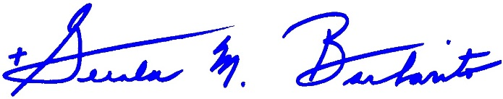

Most Reverend Gerald M. Barbarito  
 Bishop of Palm Beach

**All Pastors/Parochial Administrators:**

**Please place in your bulletin and read at all Masses the weekend of October 4th – 5th.**