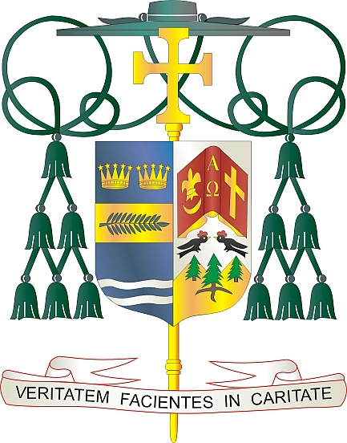

Office of  
THE BISHOP

9995 North Military Trail • P.O. Box 109650

Palm Beach Gardens, Florida 33410-9650

(561) 775-9595 Fax (561) 775-7035

## Diocese of Palm Beach

October 3, 2025

Dear Sisters and Brothers in Christ:

Next weekend, October 11/12, parishes in the Diocese of Palm Beach will conduct a second collection for World Mission Sunday, observed October 19. The 2025 World Mission Sunday theme is “Missionaries of Hope Among the Peoples,” which is inspired by the Jubilee of Hope. It is an invitation to bring Christ’s light and hope to the world, especially to communities where the Church is young, growing, and often struggling. Join us in this universal mission to spread the Gospel and share the love of Christ.

This annual collection supports more than 1,000 mission territories where the Gospel is being proclaimed for the first time, courageously upheld despite persecution, or brought to communities still discovering Christ’s love. By supporting this initiative, we join with many others to assist these missionaries and provide help for some of the most vulnerable regions in the world.

As our Holy Father, Pope Leo XIV, told representatives of the Pontifical Mission Societies in May, “Our world, wounded by war, violence and injustice, needs to hear the Gospel message of God’s love and to experience the reconciling power of Christ’s grace.” Your financial support will increase the Church’s ability to “make disciples of all nations” (Matt. 28:19).

With gratitude for your continued generosity and every prayerful wish, I am

Sincerely yours in Christ,

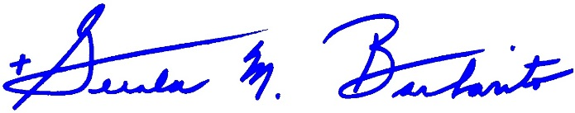

Most Reverend Gerald M. Barbarito  
 Bishop of Palm Beach

**NOTE: IT IS REQUIRED THAT YOU PUBLISH THIS LETTER IN THE PARISH BULLETIN AS A HALF PAGE OR FULL-PAGE LETTER THE WEEKEND OF OCTOBER 4/5, 2025. THE COLLECTION WILL TAKE PLACE OCTOBER 11/12, 2025. YOU ARE WELCOME TO READ THE LETTER TO PARISHIONERS, POST THIS LETTER ON SOCIAL MEDIA, AND ON YOUR WEBSITE IN ADDITION TO HAVING IT PRINTED IN THE BULLETIN.**