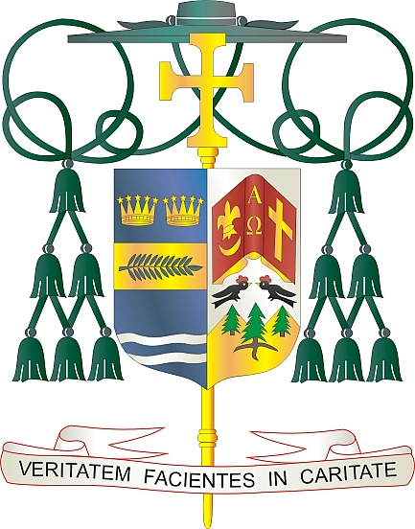
Office of
THE BISHOP

9995 North Military Trail • P.O. Box 109650
Palm Beach Gardens, Florida 33410-9650

(561) 775-9595 Fax (561) 775-7035

Diocese of Palm Beach

December 4, 2022

Dear Sisters and Brothers in Christ:

The annual collection for the Retirement Fund for Religious is next weekend, December 10 and 11. Nearly 25,000 elderly Religious Priests, Sisters, and Brothers have devoted their lives to prayer and ministry by educating youth, supporting the sick, helping the needy, etc. In their youth, these religious worked for little, or no pay, to keep the costs of Catholic education and medical care at a minimum. Because of this, no retirement savings or pension funds were set up to care for them in their senior years. Your support of the Retirement Fund for Religious helps to provide nursing care, medicine, and other necessities.

Thanks to your past support, 271 religious communities received funding in 2022, with 24,924 religious past the age of 70 benefiting from this fund. Like many Americans, religious communities face the monumental challenge of funding elder care. The Diocese of Palm Beach is grateful for your spiritual and financial assistance toward these dedicated women and men of God as they live out the final chapter in their story of faith and service.

Thank you for all that you do for our retired religious women and men, for your prayers, your friendship, your love and your generosity.

With gratitude for your continued support and every prayerful wish, I am

Sincerely yours in Christ,
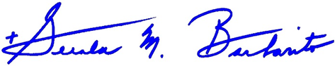

Most Reverend Gerald M. Barbarito
Bishop of Palm Beach

NOTE TO PASTORS: IT IS REQURED THAT YOU PUBLISH THIS LETTER IN THE PARISH BULLETIN AS A HALF PAGE OR FULL-PAGE LETTER THE WEEKEND OF DECEMBER 3/4, 2022. THE COLLECTION WILL TAKE PLACE DECEMBER 10/11, 2022. YOU ARE WELCOME TO READ THE LETTER TO PARISHIONERS, POST THE LETTER ON SOCIAL MEDIA, AND ON YOUR WEBSITE, IN ADDITION TO HAVING IT PRINTED IN THE BULLETIN.

