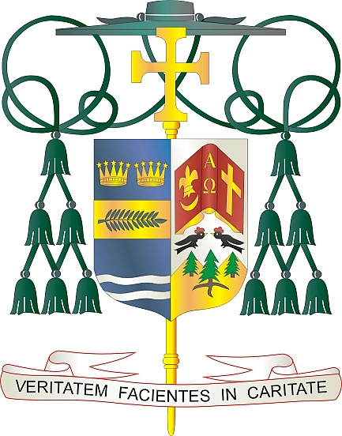

Office of  
THE BISHOP

9995 North Military Trail • P.O. Box 109650

Palm Beach Gardens, Florida 33410-9650

(561) 775-9595 Fax (561) 775-7035

## Diocese of Palm Beach

June 6, 2025

Dear Sisters and Brothers in Christ:

On the weekend, June 14/15, you are invited to support mission collections to assist the work of the missions here in the United States of America.

The Black and Indian Mission portion of the collection helps African American and Native American Catholic communities spread the Gospel and respond to ongoing needs on the ground. Established as the first national collection in 1874, this project helps missionaries to minister, catechize children and adults, and foster hope in areas where it is in short supply.

The Catholic Home Missions part of the collection supports U.S. dioceses with significant financial needs to sustain core pastoral services and missions of mercy to those they serve. Your support of this appeal makes a difference in mission communities through programs for evangelization, faith formation, human life and dignity, strengthening marriages and families, and priestly and religious vocations.

With gratitude for your continued generosity and every prayerful wish, I am

Sincerely yours in Christ,

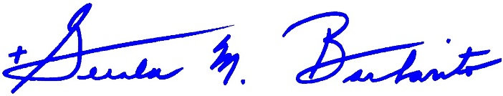

Most Reverend Gerald M. Barbarito  
 Bishop of Palm Beach

**NOTE TO PASTORS: IT IS REQUIRED THAT YOU PUBLISH THIS LETTER IN THE PARISH BULLETIN AS A HALF-PAGE OR FULL-PAGE LETTER THE WEEKEND OF JUNE 7/8, 2025. THE COLLECTION WILL TAKE PLACE JUNE 14/15, 2025. YOU ARE WELCOME TO READ THE LETTER TO PARISHIONERS, POST IT ON SOCIAL MEDIA AND ON YOUR WEBSITE, IN ADDITION TO HAVING IT PRINTED IN THE BULLETIN.**