

Office of
THE DIOCESAN
BISHOP

9995 North Military Trail • P.O. Box 109650
Palm Beach Gardens, Florida 33410-9650

(561) 775-9595 Fax (561) 775-7035

Diocese of Palm Beach

June 5, 2026

Dear Sisters and Brothers in Christ:

Next weekend, June 13/14, the Diocese of Palm Beach will collect funds for two vital causes: Black and Indian Missions and the Catholic Home Missions.

The Black and Indian Mission collection, established as the first national collection in 1874, has proven itself to be a successful vehicle for supporting the needs of our African American, Native American and Alaska Native brothers and sisters. Your support helps ensure the presence of missionaries, places Bibles and catechetical materials in the hands of priests, lay leaders and consecrated men and women, and impacts pastoral work across the country.

The Catholic Home Missions appeal provides valuable aid to dioceses and eparchies throughout the United States, as well as its territories and former territories. These home mission dioceses are unable to support essential parish operations and diocesan ministries, often due to local economic hardship, small or widely dispersed Catholic populations, or remote locations that make travel and communication difficult. Your help makes a difference in Catholic mission communities through initiatives for evangelization, faith formation, human life and dignity, strengthening marriages and families, and priestly and religious vocations.

Assuring you and all those you love of my continued remembrance in the celebration of the Holy Eucharist, and commending you to the loving intercession of the Blessed Virgin Mary, Queen of the Apostles, I remain

Sincerely yours in our Lord Jesus Christ,
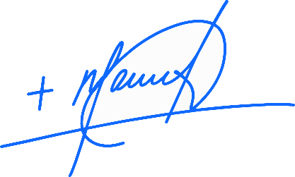
Most Reverend Manuel de Jesús Rodríguez, J.C.D.
Bishop of Palm Beach

NOTE TO PASTORS: IT IS REQUIRED THAT YOU PUBLISH THIS LETTER IN THE PARISH BULLETIN AS A HALF-PAGE OR FULL-PAGE LETTER THE WEEKEND OF JUNE 6/7, 2026. THE COLLECTION WILL TAKE PLACE JUNE 13/14, 2026. YOU ARE WELCOME TO READ THE LETTER TO PARISHIONERS, POST THIS LETTER ON SOCIAL MEDIA, AND ON YOUR WEBSITE, IN ADDITION TO HAVING IT PRINTED IN THE BULLETIN.

