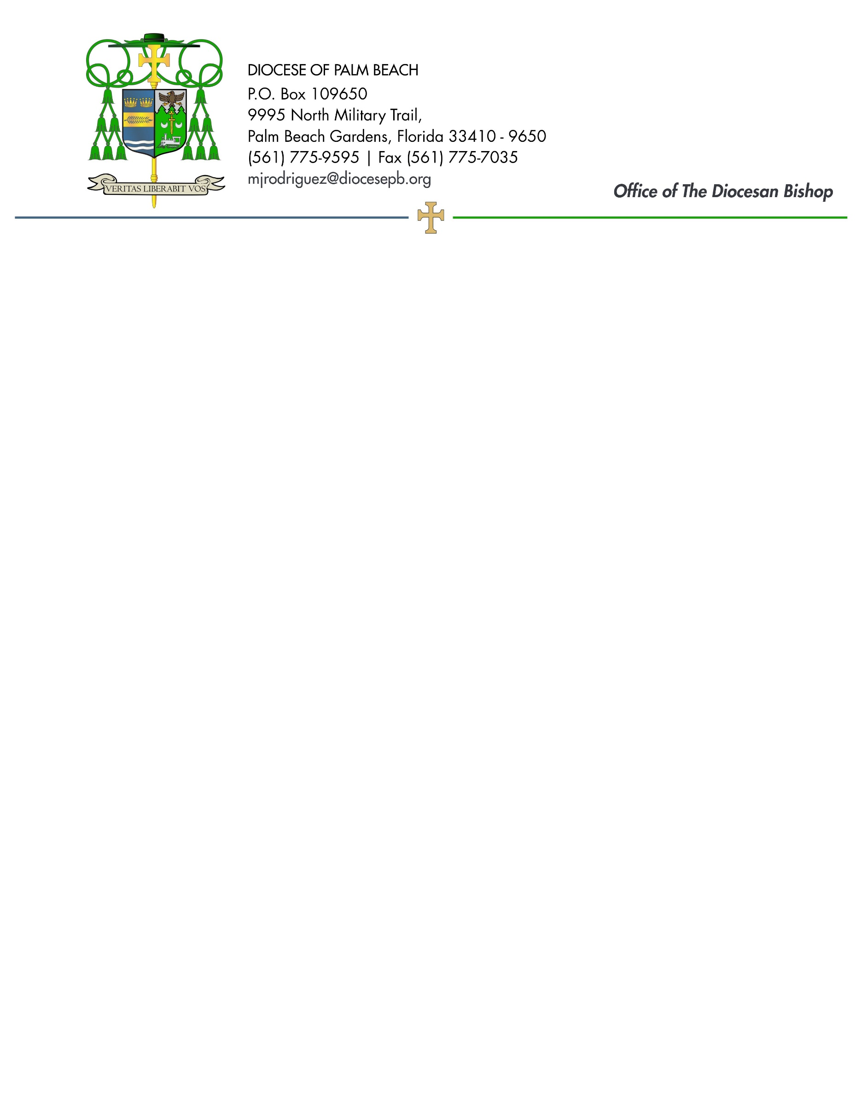
September 4, 2026

Dear Sisters and Brothers in Christ:

Next weekend, September 12/13, the Diocese of Palm Beach will collect funds to benefit our local Catholic Charities Respect Life Ministry and three diocesan parishes that minister to many migrant members.

Half of the second collection will aid our local efforts to promote respect for all human life through prayer, teaching, legislative action and pastoral programs by implementing the Respect Life Program and Pastoral Plan for Pro-Life Activities of the U.S. Conference of Catholic Bishops. The ministry honors the sacredness of life by raising awareness in such areas as abortion, physician-assisted suicide/euthanasia, death penalty, end-of-life care and bioethics.

The other part of the collection will support the parishes of St. Philip Benizi in Belle Glade, St. Mary in Pahokee and Holy Cross in Indiantown. Those faith communities have large migrant populations, and your contribution assists the parishes greatly in ministering to their diverse pastoral and social needs. Your prayerful and compassionate response to this collection will help change the lives of those who cry out to God in need as they seek a safe home for their hard-working families.

Assuring you and all those you love of my continued remembrance in the celebration of the Holy Eucharist, and commending you to the loving intercession of the Blessed Virgin Mary, Queen of the Apostles, I remain

Sincerely yours in our Lord Jesus Christ,
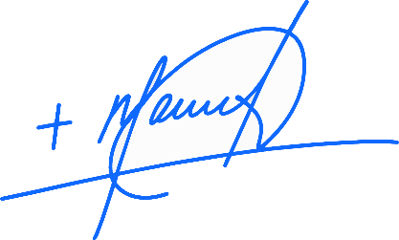
Most Reverend Manuel de Jesús Rodríguez, J.C.D.
Bishop of Palm Beach

NOTE TO PASTORS: IT IS REQUIRED THAT YOU PUBLISH THIS LETTER IN THE PARISH BULLETIN AS A HALF-PAGE OR FULL-PAGE LETTER THE WEEKEND OF SEPTEMBER 5/6. THE COLLECTION WILL TAKE PLACE SEPTEMBER 12/13, 2026. YOU ARE WELCOME TO READ THE LETTER TO PARISHIONERS, POST THIS LETTER ON SOCIAL MEDIA, AND ON YOUR WEBSITE IN ADDITION TO HAVING IT PRINTED IN THE BULLETIN.

