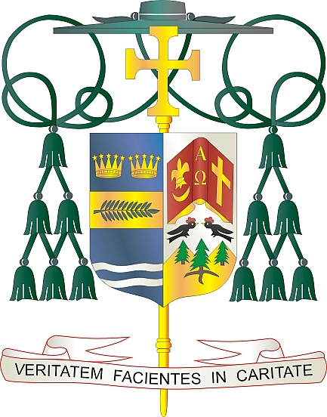
Office of
THE BISHOP

9995 North Military Trail • P.O. Box 109650
Palm Beach Gardens, Florida 33410-9650

(561) 775-9595 Fax (561) 775-7035

Diocese of Palm Beach

March 4, 2023

Dear Sisters and Brothers in Christ:

Next weekend, March 11th and 12th is the annual Diocese of Palm Beach collection for the education of seminarians and the formation of priests. The funds raised in this collection are used to support the cost of tuition, housing, education, and pastoral training of our seminarians. For example, the cost of tuition for one seminarian per year is $22,000, and the room and board for one seminarian is $12,100 per year. The priestly discernment and seminary formation process is important, and these seminarians need our spiritual and financial support.

Currently, there are eight seminarians from our Diocese who are dedicating themselves to this important process of understanding their vocation. With God’s grace, we will have two ordinations this year: one priestly ordination (Rev. Mr. Marc Gustinelli) and one diaconate ordination (Mr. Joshua Martin).

By your generosity, our seminarians can devote themselves fully to the task of priestly formation, without having to worry about the financial burden of seminary. With them, you walk the journey of faith and ensure that the sacraments will continue to nourish the faithful for generations to come.

With gratitude for your continued generosity and every prayerful wish, I am

Sincerely yours in Christ,
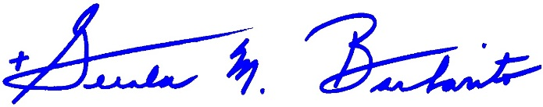
Most Reverend Gerald M. Barbarito
Bishop of Palm Beach

NOTE TO PASTORS: IT IS REQUIRED THAT YOU PUBLISH THIS LETTER IN THE PARISH BULLETIN AS A HALF-PAGE OR FULL-PAGE LETTER THE WEEKEND OF MARCH 4/5, 2023. THE COLLECTION WILL TAKE PLACE MARCH 11/12, 2023. YOU ARE WELCOME TO READ THE LETTER TO PARISHIONERS, POST THIS LETTER ON SOCIAL MEDIA, AND ON YOUR WEBSITE IN ADDITION TO HAVING IT PRINTED IN THE BULLETIN.

