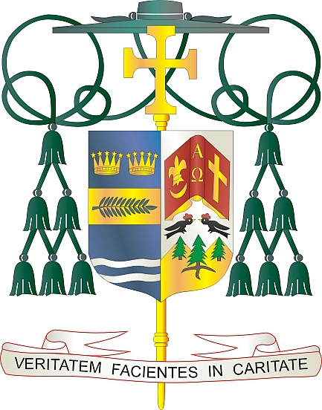
Office of
THE BISHOP

9995 North Military Trail • P.O. Box 109650
Palm Beach Gardens, Florida 33410-9650

(561) 775-9595 Fax (561) 775-7035

Diocese of Palm Beach

April 17, 2021

Dear Brothers and Sisters in Christ:

On April 24 and 25, 2021, our diocese will participate in the annual Peter’s Pence Collection. The funds raised from this annual collection allow the Holy Father to respond to humanitarian disasters around the world. From assisting the recent earthquake victims in Croatia and Albania, or the refugee crisis in the Mediterranean, to free medical clinics, the Peter’s Pence collection enables the Successor of Peter to respond to the needs of God’s children.

As the expression itself signifies Peter’s Pence, represents an offering, no matter how small, that has great meaning. Indeed, its value is not only practical, but is also highly symbolic. It represents a sign of communion with the Pope. For this reason, Peter’s Pence is also the manifestation of a sense of belonging to the Church and of love for her visible head (www.obolodesanpietro.va ).
By participating in the Peter’s Pence Collection, you enable the Holy Father’s charitable outreach to those most in need. Please prayerfully consider how you can best support the collection this year. For more information about the collection, please visit www.usccb.org/peters-pence .

With gratitude for your continued generosity and every prayerful wish, I am

Sincerely yours in Christ,
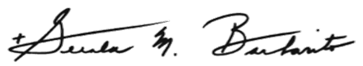

Most Reverend Gerald M. Barbarito
Bishop of Palm Beach

NOTE TO PASTORS: IT IS REQUIRED THAT YOU PUBLISH THIS LETTER IN THE PARISH BULLETIN AS A HALF PAGE OR FULL-PAGE LETTER THE WEEKEND OF APRIL 17/18, 2021. THE COLLECTION WILL TAKE PLACE APRIL 24/25, 2021. YOU ARE WELCOME TO READ THE LETTER TO PARISHIONERS, POST THIS LETTER ON SOCIAL MEDIA, AND ON YOUR WEBSITE IN ADDITION TO HAVING IT PRINTED IN THE BULLETIN.

