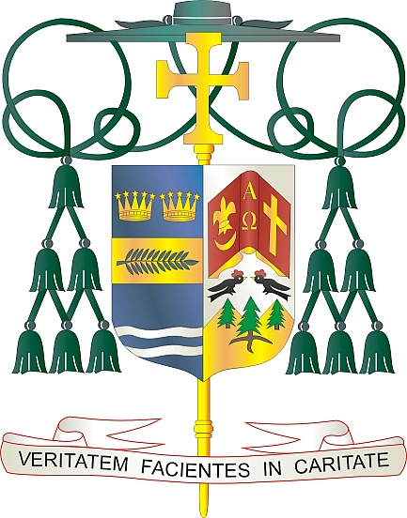
Office of
THE BISHOP

9995 North Military Trail • P.O. Box 109650
Palm Beach Gardens, Florida 33410-9650

(561) 775-9595 Fax (561) 775-7035

Diocese of Palm Beach

February 11, 2023

Dear Sisters and Brothers in Christ:

Next weekend, February 18th and 19th, the Diocese of Palm Beach will have a second collection to support our local priests who have retired. The money raised from this collection helps support the dozens of retired priests in the five counties of our diocese. These priests, who have blessed us with years of service to the Lord, remain valued members of our diocese, with many continuing to serve the faithful in a variety of ways.

Your support of our retired priests, through your prayers and generosity, is greatly appreciated. Thank you in advance for allowing them to continue to be faithful stewards and supporting their needs in retirement. In addition to supporting them financially, we also ask that you pray for our retired priests during this same weekend.

With gratitude for your continued generosity and every prayerful wish, I am

Sincerely yours in Christ,
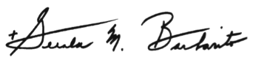

Most Reverend Gerald M. Barbarito
Bishop of Palm Beach

NOTE TO PASTORS: IT IS REQUIRED THAT YOU PUBLISH THIS LETTER IN THE PARISH BULLETIN AS A HALF-PAGE OR FULL-PAGE LETTER THE WEEKEND OF FEBRUARY 11/12, 2023. THE COLLECTION WILL TAKE PLACE FEBRUARY 18/19, 2023. YOU ARE WELCOME TO READ THE LETTER TO PARISHIONERS, POST THIS LETTER ON SOCIAL MEDIA, AND ON YOUR WEBSITE IN ADDITION TO HAVING IT PRINTED IN THE BULLETIN.

