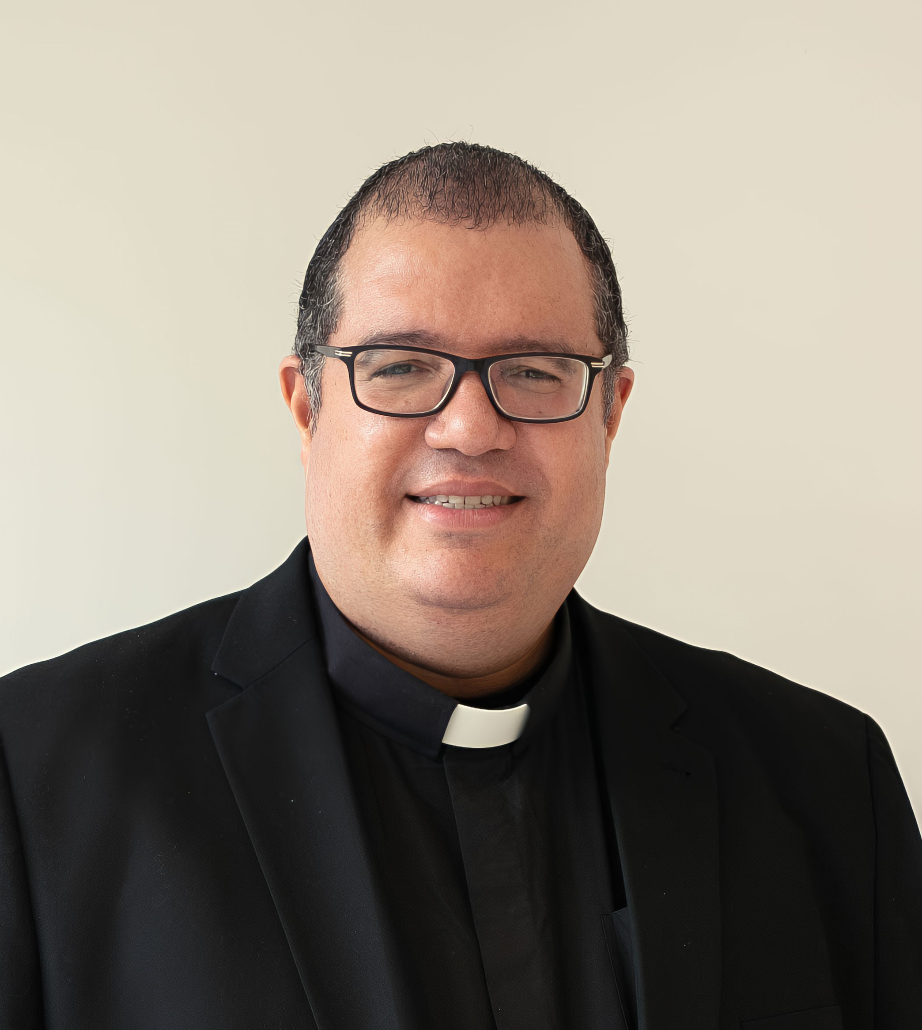
CURRICULUM VITAE

Rev. Manuel de Jesús Rodríguez, LL.B., J.C.D.
Diocese of Brooklyn, New York, NY

PERSONAL PROFILE
Catholic priest and canon lawyer with extensive experience in penal canon law and pastoral leadership. Currently serving in senior juridical roles within the Diocese of Brooklyn, including Promoter of Justice and Delegate of the Diocesan Bishop for Penal Cases. Combines advanced canonical scholarship, international academic formation, and long-standing parish leadership.

ORDINATION & INCARDINATION
- Diaconal Ordination: June 29, 2003 – Rome, Italy
- Presbyteral Ordination: July 3, 2004 – Santo Domingo, Dominican Republic
- Incardination: Diocese of Brooklyn – June 29, 2012

EDUCATION
- Doctor of Canon Law (J.C.D.), University of Navarra, Pamplona, Spain, 2024
- Licentiate in Canon Law (J.C.L.), The Catholic University of America, Washington, DC, 2016
- M.S. in Education, Universidad INTEC, Santo Domingo, Dominican Republic, 2008
- M.S. in Administration of Educational Centers, Universidad INTEC, Santo Domingo, Dominican Republic, 2005
- B.A. in Theology, Pontificia Università Salesiana, Rome, Italy, 2003
- B.A. in Law, Pontificia Universidad Católica Madre y Maestra, Dominican Republic, 1998
- B.A. in Education (Literature Specialization), Universidad Católica Santo Domingo, Dominican Republic, 1997
- B.A. in Philosophy, Pontificia Universidad Católica Madre y Maestra, Dominican Republic, 1996

DIOCESAN & CANONICAL APPOINTMENTS
- Promoter of Justice, Diocese of Brooklyn (2025–present)
- Delegate of the Diocesan Bishop for Penal Cases, Diocese of Brooklyn (2025–present)
- Defender of the Bond, Diocese of Brooklyn (2017–present)
- Priest Instructor for Cases of Removal from the Clerical State, Diocese of Brooklyn (2016–present)

PASTORAL LEADERSHIP
- Pastor, Our Lady of Sorrows Parish, Corona (Queens), NY (2020–present)
- Pastor, Presentation of the Blessed Virgin Mary Parish, Jamaica (Queens), NY (2014–2020)
- Pastor, Saints Peter and Paul Parish, Williamsburg (Brooklyn), NY (2011–2014)
- Parochial Vicar, Saint Michael Parish, Sunset Park (Brooklyn), NY (2009–2011)

ACADEMIC & FORMATION EXPERIENCE
- Theology and Canon Law Instructor, Holy Spirit Institute, Diocese of Brooklyn (2009–2020)
- Professor of Philosophy and Professional Ethics, Pontificia Universidad Católica Madre y Maestra (1996–1998; 2004–2009)

LANGUAGES
Spanish (native) · English (fluent) · Italian (fluent) · French (fluent)

Updated December 18, 2025, 2:30 p.m.

