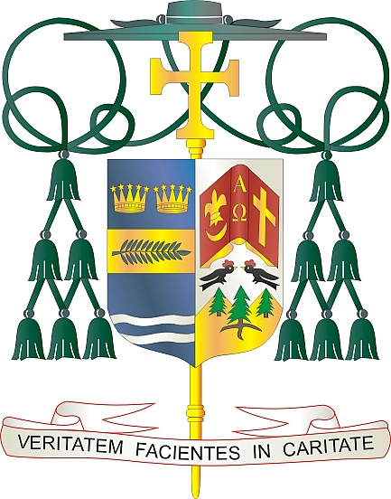

Office of  
THE BISHOP

9995 North Military Trail • P.O. Box 109650

Palm Beach Gardens, Florida 33410-9650

(561) 775-9595 Fax (561) 775-7035

## Diocese of Palm Beach

August 1, 2025

Dear Brothers and Sisters in Christ:

Next weekend, August 9/10, parishes in our Diocese will collect funds to support the Church in Latin America and the Solidarity Fund for the Church in Africa. The proceeds will be split between these two vital initiatives that reach people most in need and bring them pastoral care.

For more than 50 years, Catholics in the United States have expressed a closer unity with and love for their brothers and sisters in Central and South America and the Caribbean islands. When you participate in the collection, you support special events, the ongoing work of forming catechists, supporting vocations to priesthood and religious life, and implementing family ministries among some of the poorest and most culturally diverse areas in the world.

The Church in Africa leads the way in healing wounds of division and conflict, preaching the Gospel, and reconciling people in hope for just and lasting peace. Your support of the Solidarity Fund for the Church in Africa empowers the Church to fulfill its mission as peacemaker to those who have most suffered fear and violence. Your donation will help to renew faith, strengthen families, and support formation programs for clergy and religious. By contributing to this collection, you will make a difference in countless lives.

With gratitude for your continued generosity and with every prayerful wish, I am

Sincerely yours in Christ,

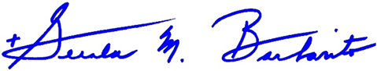

Most Reverend Gerald M. Barbarito  
 Bishop of Palm Beach

**NOTE TO PASTORS: IT IS REQUIRED THAT YOU PUBLISH THIS LETTER IN THE PARISH BULLETIN AS A HALF-PAGE OR FULL-PAGE LETTER THE WEEKEND OF AUGUST 2/3. THE COLLECTION WILL TAKE PLACE AUGUST 9/10, 2025. YOU ARE WELCOME TO READ THE LETTER TO PARISHIONERS, POST THIS LETTER ON SOCIAL MEDIA, AND ON YOUR WEBSITE IN ADDITION TO HAVING IT PRINTED IN THE BULLETIN.**