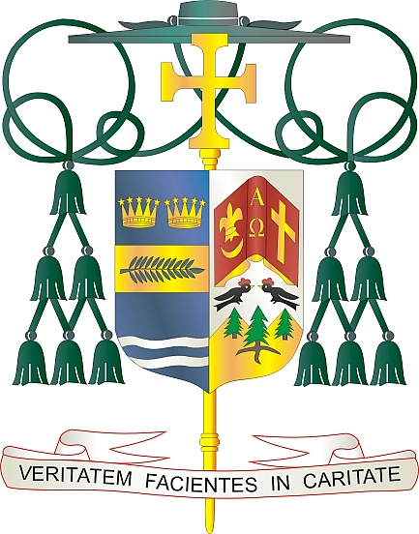

Office of  
THE BISHOP

9995 North Military Trail • P.O. Box 109650

Palm Beach Gardens, Florida 33410-9650

(561) 775-9595 Fax (561) 775-7035

## Diocese of Palm Beach

July 2025

Dear Brothers and Sisters in Christ:

Natural Family Planning (NFP) Awareness Week is an annual, national educational campaign sponsored by the United States Conference of Catholic Bishops (USCCB) to raise awareness and celebrate God’s design for married love and the gift of life. The USCCB document *Married Love and the Gift of Life* clarifies how NFP supports Catholic beliefs about married love because it “respects the God-given power to love a new human life into being.” Modern NFP, based on scientific methods, enables couples to participate in God’s creative action while addressing their human need to plan their families while avoiding the devastating spiritual and physical harm caused by artificial contraceptive methods.

This year NFP Awareness Week is being observed from July 20 through July 26 with the theme: *Pursue a lasting love… Marriage. Create hope for the future! Natural Family Planning, Supporting God’s gifts of love and life in marriage.* During this weeklong celebration, we highlight the anniversary of Humanae Vitae (July 25) which articulates Catholic beliefs about human sexuality, conjugal love, and responsible parenthood. In addition, we observe the feast of Saints Joachim and Anne (July 26), the parents of the Blessed Mother and grandparents of Jesus.

As always, but especially during NFP Awareness Week, I would like to congratulate those married couples who live out their marriage commitment to free, total, faithful, and fruitful love. I encourage all married couples and those preparing for marriage to reflect on their current or future marriages and how they can authentically and responsibly fulfill their commitment to fruitful love. If you have not yet considered NFP or have questions, I encourage you to investigate and discover the richness of NFP. Please visit our website at [www.diocesepb.org/naturalfamilyplanning](http://www.diocesepb.org/naturalfamilyplanning) for resources and additional information or call 561-775-9557.

With every prayerful wish, I am

Sincerely yours in Christ,

 Most Reverend Gerald M. Barbarito  
 Bishop of Palm Beach