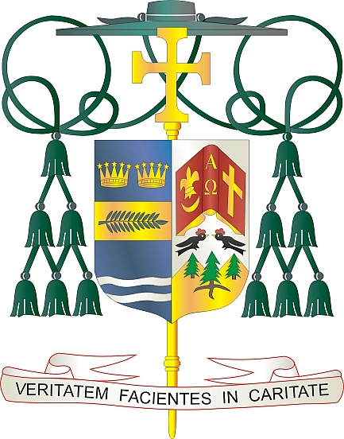

Office of  
THE BISHOP

9995 North Military Trail • P.O. Box 109650

Palm Beach Gardens, Florida 33410-9650

(561) 775-9595 Fax (561) 775-7035

## Diocese of Palm Beach

October 2, 2022

Dear Sisters and Brothers in the Lord:

On this *Respect Life Sunday,* October 2, at the beginning of the annual Respect Life Program entitled, *Called to Serve Moms in Need*, we have much to be grateful for regarding the positive advances in the acknowledgment of respect for life within our culture and nation. The Supreme Court decision of June 24, 2022, was a watershed moment in reversing almost 50 years of legalized abortion within our nation through its tragic decision of Roe v. Wade. However, there is still so much more that continues to challenge us in regard to engendering a respect for the sacredness of human life from the moment of conception until natural death.

There is a need to continue, in a Christian and positive manner, to deal with the harsh opposition which has arisen against the recent Supreme Court decision. We must do all we can, through proper legal persuasion and prayer, to curtail state legislation permitting abortion. In keeping with this year’s emphasis, *Called to Serve Moms in Need*, we need to continue to provide assistance and to walk with women who have found themselves in a difficult situation through a pregnancy, as well as after the birth of their child. In the Diocese of Palm Beach, our Catholic Charities outreach excels in this mission as it continues to expand these services which we fully support.

Abortion is a foundational issue in regard to respect for life. However, it is not the only issue and does not in any manner lessen the emphasis that must be made regarding the respect for life on behalf of the person on death row, the elderly, the sick, the immigrant, and any person whose right to life and well-being are undermined in our culture today.

I wish to thank all of you, the faithful men and women of our Diocese, who are witnesses to life and continue to pray for and support laws and programs that respect life. You make a tremendous difference, and it is an inspiration to know you. May the Lord continue to bless you, your families and all your efforts. We all join together on this *Respect Life Sunday* in recommitting ourselves to the sanctity of life and to serving moms in need.

With every prayerful wish, I am

Sincerely yours in Christ,

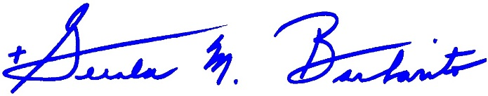

Most Reverend Gerald M. Barbarito  
 Bishop of Palm Beach

**All Pastors/Parochial Administrators:**

**Please place in your bulletin and read at all Masses the weekend of October 1st and 2nd.**