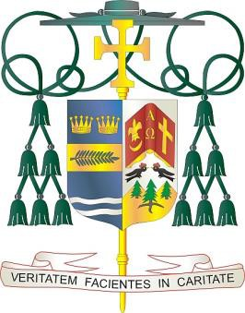
Diocese of Palm Beach
9995 North Military Trail • P.O. Box 109650 Palm Beach Gardens, Florida 33410-9650

(561) 775-9595 Fax (561) 775-7035

September 3, 2022

Dear Sisters and Brothers in Christ:

Office of THE BISHOP

Next weekend, September 10 and 11, the Diocese of Palm Beach will have a second collection to benefit both our local Catholic Charities Respect Life Ministry and three diocesan parishes that minister to mostly migrant parishioners. The funds donated in this collection will stay here within our diocese.
Half of next week’s second collection will benefit our local ministry that promotes respect for life from conception until natural death through prayer, catechesis, legislative action and pastoral programs. It actively encourages respect for all life by advocating and raising awareness in such areas as: abortion, physician-assisted suicide/euthanasia, death penalty, end of life, and bioethics. This ministry endorses and implements the Respect Life Program and the Pastoral Plan for Pro-Life Activities of the U.S. Conference of Catholic Bishops.
The other half of the collection will benefit St. Philip Benizi Catholic Church in Belle Glade, St. Mary Catholic Church in Pahokee, and Holy Cross Catholic Church in Indiantown. These parishes have large migrant communities, and your support assists them greatly in ministering to their pastoral and social needs.
Together, let us prayerfully and compassionately respond in faith to those who cry out to God in desperation as they seek a safe place for themselves and their families.
With gratitude for your continued generosity and with every prayerful wish, I am

Sincerely yours in Christ,
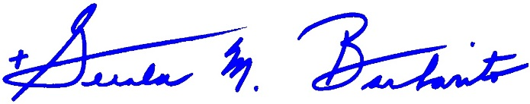
Most Reverend Gerald M. Barbarito Bishop of Palm Beach

NOTE TO PASTORS: IT IS REQUIRED THAT YOU PUBLISH THIS LETTER IN THE PARISH BULLETIN AS A HALF PAGE OR FULL-PAGE LETTER THE WEEKEND OF SEPTEMBER 3/4, 2022. THE COLLECTION WILL TAKE PLACE SEPTEMBER 10/11, 2022. YOU ARE WELCOME TO READ THE LETTER TO PARISHIONERS, POST THIS LETTER ON SOCIAL MEDIA, AND ON YOUR WEBSITE IN ADDITION TO HAVING IT PRINTED IN THE BULLETIN.

