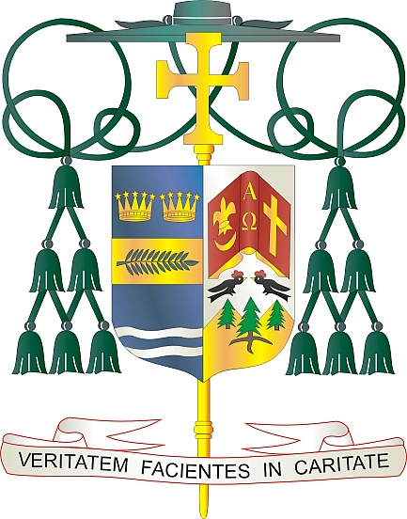
Office of
THE BISHOP

9995 North Military Trail • P.O. Box 109650
Palm Beach Gardens, Florida 33410-9650

(561) 775-9595 Fax (561) 775-7035

Diocese of Palm Beach

April 9, 2022

Dear Sisters and Brothers in Christ:

Pope Francis has asked parishes to support the annual Pontifical Good Friday Collection, to be held on April 15, 2022. This annual second collection is taken in Catholic churches throughout the world to support the work of the Franciscans working in the Holy Land. Specifically, the collection, funds Catholic schools, offers religious education, and helps to preserve the sacred shrines.

Last year’s Pontifical Good Friday Collection supported numerous initiatives, including 23 parishes and three academic institutions, provided a home for 30 children from homes facing domestic violence, offered 400 scholarships for high school and university education, helped keep schools open for more than 10,000 pre-K through grade 12 students, supported 120 men preparing to be priests or brothers, restored and maintained more than 1,000 houses/apartments for Christian families, offered assistance at senior care facilities in Bethlehem and Nazareth, created 1,200 jobs in the Holy Land for Christians, and preserved 65 shrines connected with the life of Jesus and the prophets.

Thank you for supporting the Pontifical Good Friday Collection, as encouraged by Pope Francis. By supporting this cause, you join with Catholics around the world to stand in solidarity with the Church in the Holy Land, and you become an instrument of peace in a troubled land.

With gratitude for your continued generosity and every prayerful wish, I am

Sincerely yours in Christ,
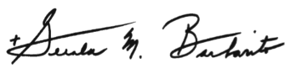

Most Reverend Gerald M. Barbarito
Bishop of Palm Beach

NOTE TO PASTORS: IT IS REQUIRED THAT YOU PUBLISH THIS LETTER IN THE PARISH BULLETIN AS A HALF-PAGE OR FULL-PAGE LETTER THE WEEKEND OF APRIL 9/10, 2022. THE COLLECTION WILL TAKE PLACE APRIL 15, 2022. YOU ARE WELCOME TO READ THE LETTER TO PARISHIONERS, POST THIS LETTER ON SOCIAL MEDIA, AND ON YOUR WEBSITE, IN ADDITION TO HAVING IT PRINTED IN THE BULLETIN.

