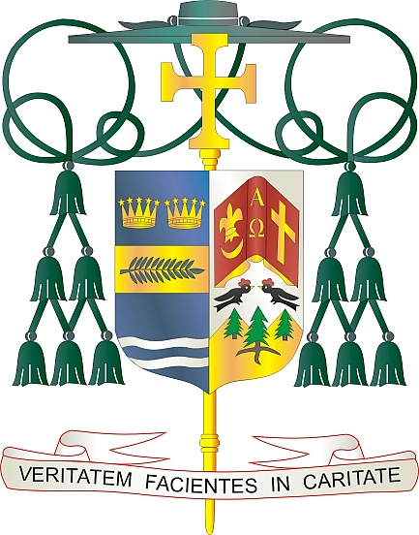
Office of
THE BISHOP

9995 North Military Trail • P.O. Box 109650
Palm Beach Gardens, Florida 33410-9650

(561) 775-9595 Fax (561) 775-7035

Diocese of Palm Beach

December 4, 2021

Dear Sisters and Brothers in Christ:

The annual collection for the Retirement Fund for Religious is next weekend, December 11 and 12. In 1988, the United States Catholic bishops initiated the Retirement Fund for Religious to address the deficit in retirement savings among religious communities. Proceeds from the collection help communities across the country to provide for the needs of aging members.

Thanks to your past support, 321 religious communities received funding in 2021, with 26,330 religious past the age of 70 benefiting from this fund. Specifically, the National Religious Retirement Office coordinates the distribution of the proceeds to eligible communities, which provide financial assistance, consultation and education that help religious communities meet the immediate and ongoing needs of aging members. Roughly 95 percent of their budget aids senior religious.

Like many Americans, religious communities face the monumental challenge of funding eldercare. The Diocese of Palm Beach is grateful for your spiritual and financial assistance toward these dedicated women and men of God as they live out the final chapter in their story of faith and service.

Thank you for all that you do for our retired religious women and men, for your prayers, your friendship, your love and your generosity.

With gratitude for your continued support and every prayerful wish, I am

Sincerely yours in Christ,
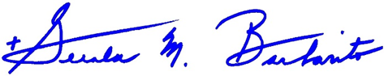

Most Reverend Gerald M. Barbarito
Bishop of Palm Beach

NOTE TO PASTORS: IT IS REQURED THAT YOU PUBLISH THIS LETTER IN THE PARISH BULLETIN AS A HALF PAGE OR FULL-PAGE LETTER THE WEEKEND OF DECEMBER 4/5, 2021. THE COLLECTION WILL TAKE PLACE DECEMBER 11/12, 2021. YOU ARE WELCOME TO READ THE LETTER TO PARISHIONERS, POST THE LETTER ON SOCIAL MEDIA, AND ON YOUR WEBSITE, IN ADDITION TO HAVING IT PRINTED IN THE BULLETIN.

