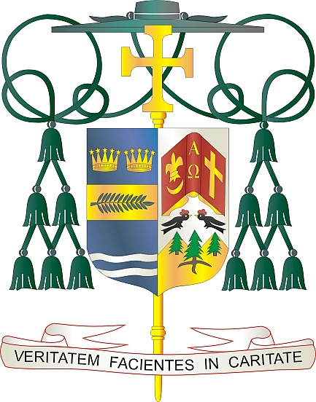
Office of
THE BISHOP

9995 North Military Trail • P.O. Box 109650
Palm Beach Gardens, Florida 33410-9650

(561) 775-9595 Fax (561) 775-7035

Diocese of Palm Beach

October 1, 2022

Dear Sisters and Brothers in Christ:

Next weekend, the parishes in our diocese will participate in a second collection for World Mission Sunday, observed on October 23, 2022. World Mission Sunday honors the modern missionaries of the Church who follow the Gospel mandate to go out and preach to all nations. Pope Francis’ message for World Mission Sunday this year urges all Christians to proclaim Christ’s message of salvation in every aspect of our daily lives. The theme for 2022 is: “You shall be my witnesses” (Acts 1:8). The Pope expressed his desire that we all embrace our vocation as missionary disciples of Christ.

The collection supports more than a thousand local churches in Asia and Africa, the Pacific Islands, and parts of Latin America and Europe. When we support this collection, we join together to aid these missions and ministries, and provide help for some of the most vulnerable communities around the world.

As Pope Francis said in his address regarding World Mission Sunday: “Would that all of us in the Church were what we already are by virtue of baptism: prophets, witnesses, missionaries of the Lord, by the power of the Holy Spirit, to the ends of the earth! Mary, Queen of the Missions, pray for us!”

With gratitude for your continued generosity and every prayerful wish, I am

Sincerely yours in Christ,
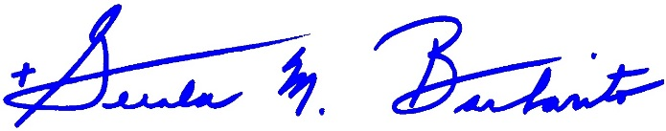
Most Reverend Gerald M. Barbarito
Bishop of Palm Beach

NOTE: IT IS REQUIRED THAT YOU PUBLISH THIS LETTER IN THE PARISH BULLETIN AS A HALF PAGE OR FULL-PAGE LETTER THE WEEKEND OF OCTOBER 1/2, 2022. THE COLLECTION WILL TAKE PLACE OCTOBER 8/9, 2022. YOU ARE WELCOME TO READ THE LETTER TO PARISHIONERS, POST THIS LETTER ON SOCIAL MEDIA, AND ON YOUR WEBSITE IN ADDITION TO HAVING IT PRINTED IN THE BULLETIN.

