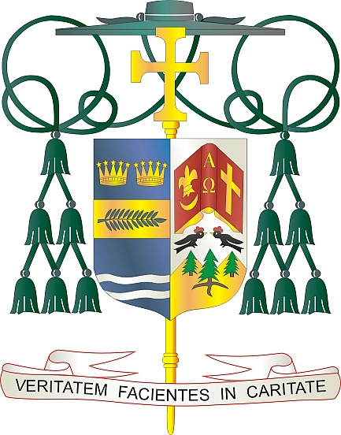

Office of  
THE BISHOP

9995 North Military Trail • P.O. Box 109650

Palm Beach Gardens, Florida 33410-9650

(561) 775-9595 Fax (561) 775-7035

## Diocese of Palm Beach

July 3, 2025

Dear Sisters and Brothers in Christ:

Next weekend, July 12/13, our parishes will collect funds to support the global reach of Catholic Relief Services, revealing Christ’s love to victims of trafficking, war and natural disaster around the world and here in the United States, and making possible faith-enriching, life-changing pastoral ministries and encounters.

In addition to aiding those with immediate needs, your assistance helps long-term efforts to build peace in regions that have been affected by decades of conflict. CRS works to meet basic humanitarian needs, protect vulnerable children, reunite families and encourage legislation that reflects the importance of family in society. Your aid makes a difference for so many around the globe.

Thank you for prayerfully considering how you can support this 2025 collection. To learn more about the collection and the people who benefit from it, please visit [*www*.*usccb*.*org/catholic-relief*](http://www.usccb.org/catholic-relief). May God continue to bless you with every grace and strength, and may our Blessed Mother always intercede for you.

With gratitude for your continued generosity and every prayerful wish, I am

Sincerely yours in Christ,

Most Reverend Gerald M. Barbarito  
 Bishop of Palm Beach

**NOTE TO PASTORS: IT IS REQUIRED THAT YOU PUBLISH THIS LETTER IN THE PARISH BULLETIN AS A HALF-PAGE OR FULL-PAGE LETTER THE WEEKEND OF JULY 5/6, 2025. THE COLLECTION WILL TAKE PLACE JULY 12/13, 2025. YOU ARE WELCOME TO READ THE LETTER TO PARISHIONERS, POST THE LETTER ON SOCIAL MEDIA, AND ON YOUR WEBSITE, IN ADDITION TO HAVING IT PRINTED IN THE BULLETIN.**