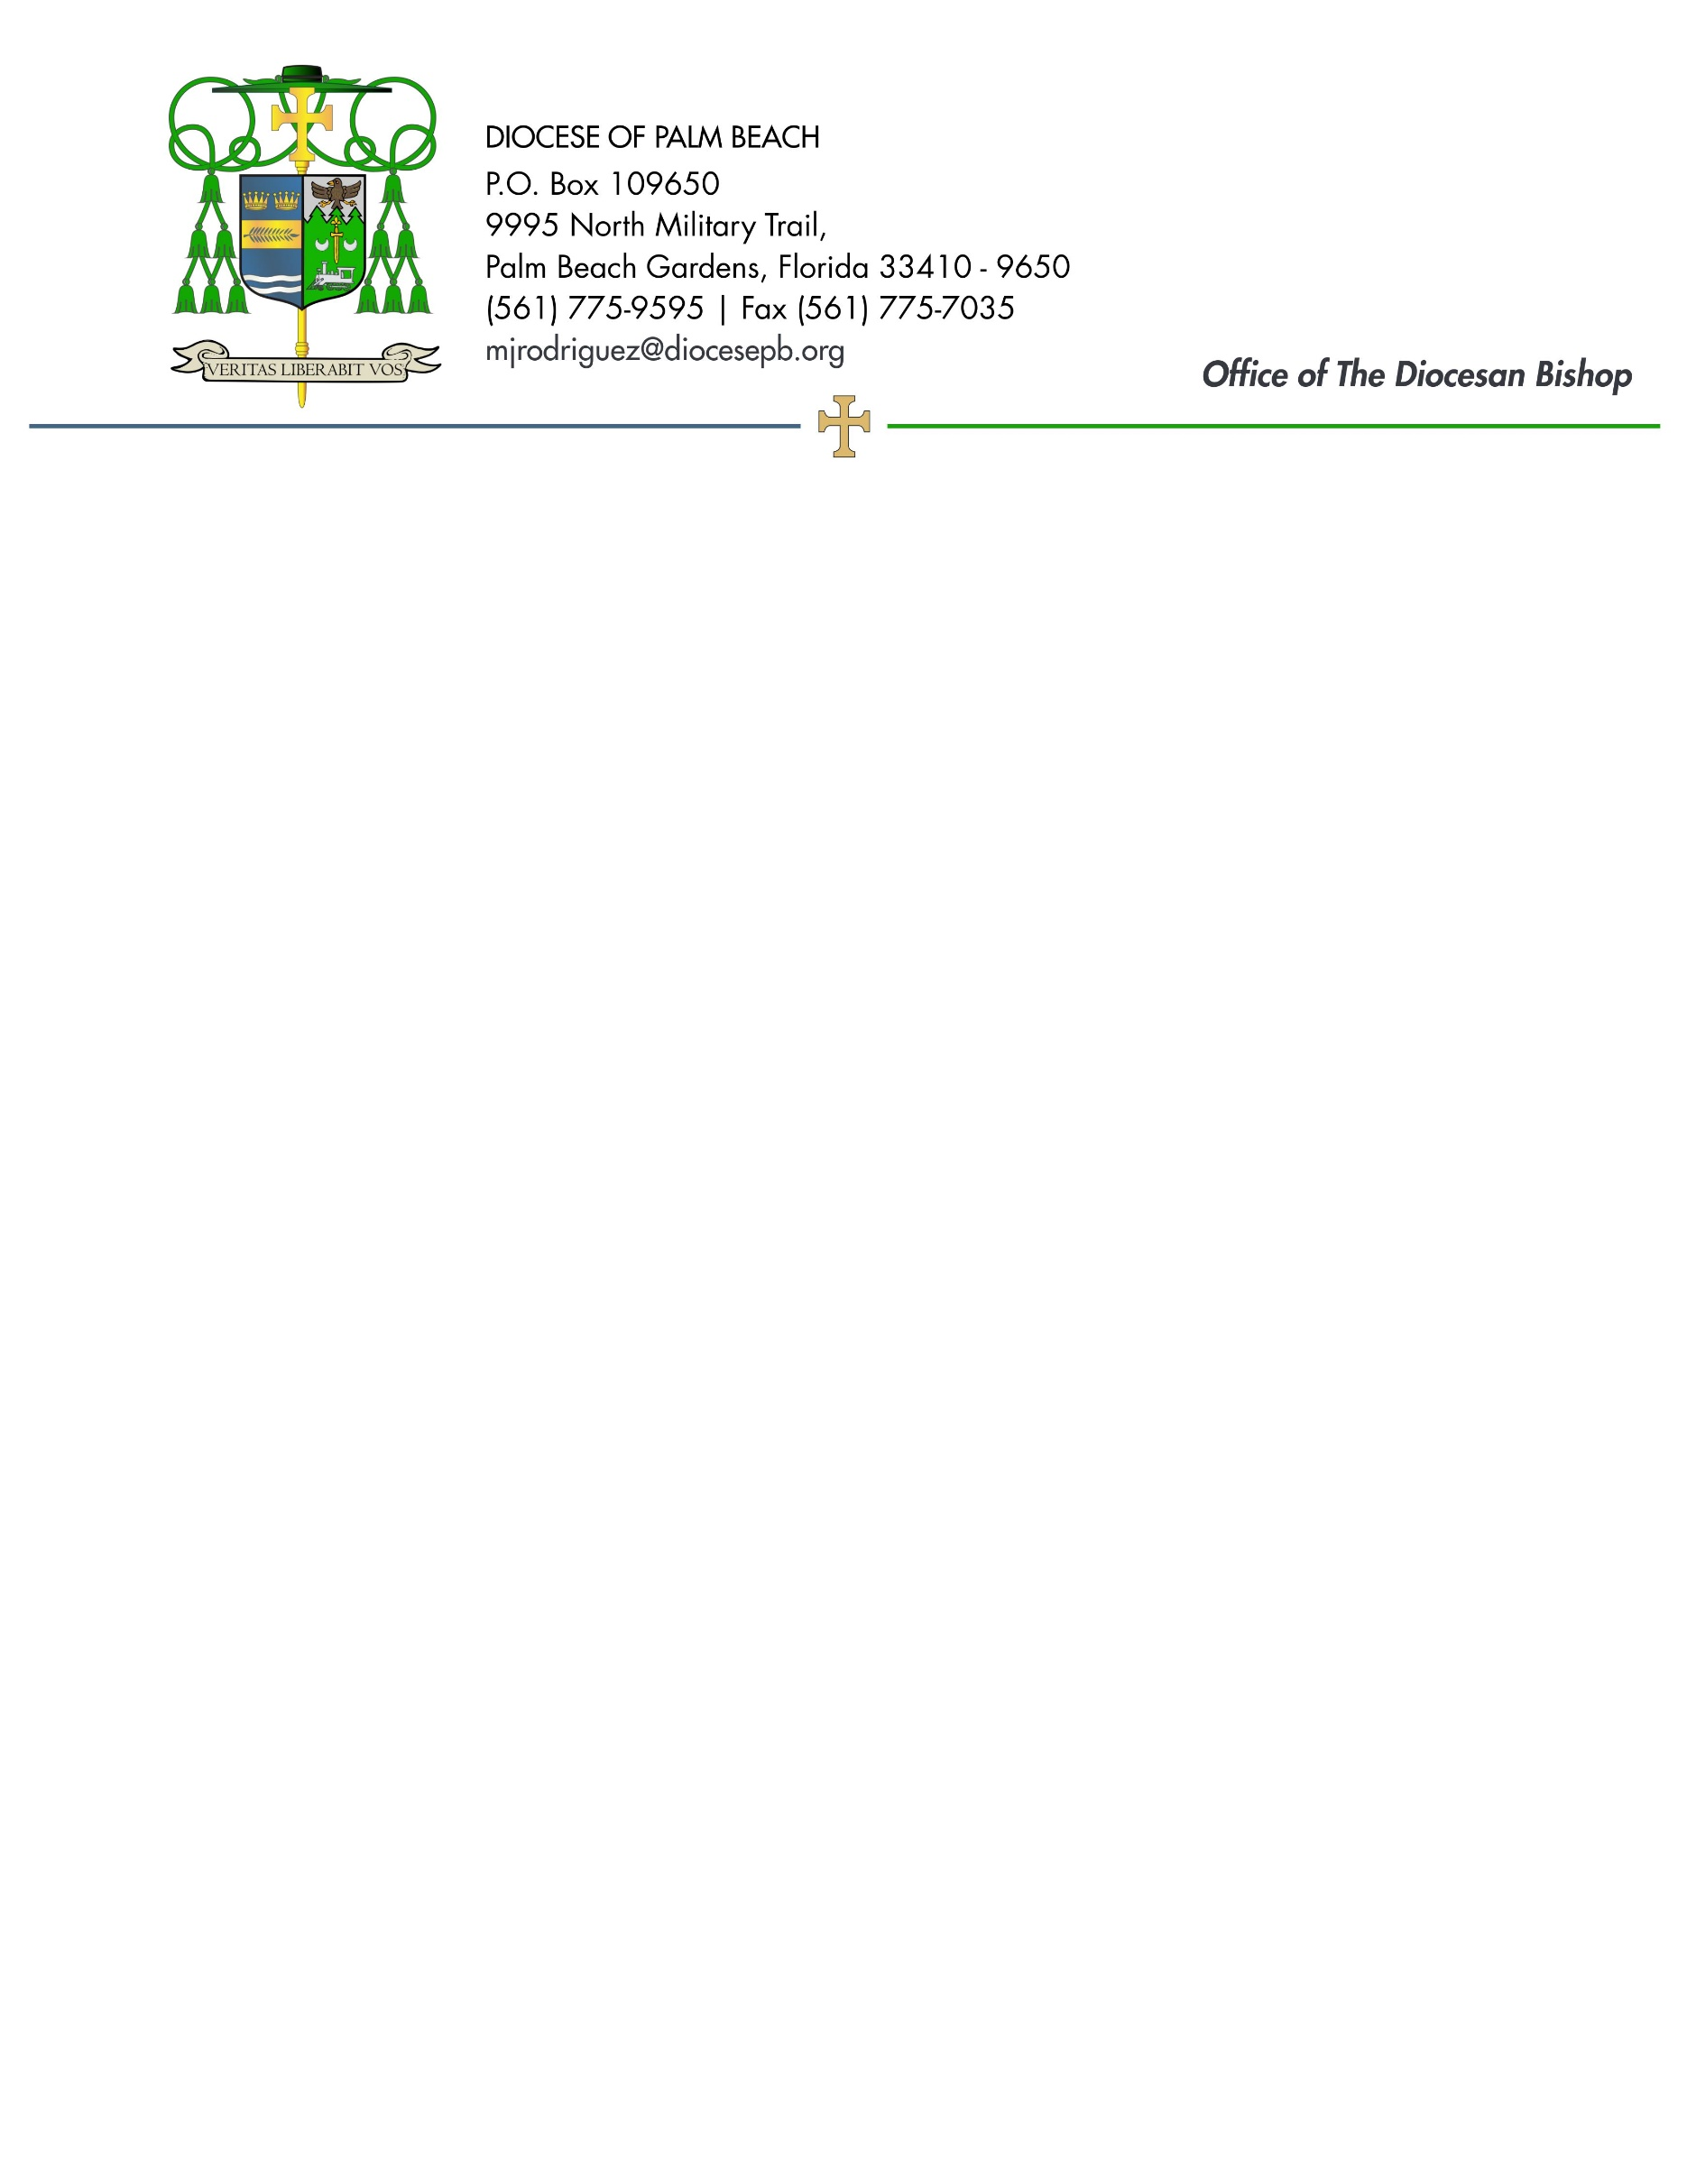
July 3, 2026

Dear Sisters and Brothers in Christ:

All of our parishes will take up a collection next weekend, July 11/12, to support Catholic Relief Services, which provides aid to vulnerable people affected by war, natural disasters, and exploitation.

Human trafficking is the exploitation of a person compelled through force, fraud, or coercion to provide work or service, regardless of nationality, citizenship or geographic location. Poverty, isolation from the support of family and friends, and cultural or language barriers are among the factors that place people at risk of trafficking. In light of these challenges, successful anti-trafficking efforts must involve communities that can recognize the signs of trafficking and provide direct assistance to victims. School teachers, parish staff and clergy, and health care providers at community clinics — with training to recognize the signs of human trafficking in their own communities — can be effective in combatting the exploitation of those they serve.

With funds received through the annual Catholic Relief Services collection, the Office of Migration and Refugee Services (MRS) of the U.S. Conference of Catholic Bishops launched a pilot program to combat human trafficking in certain U.S. dioceses. Working with local partners, MRS staff assessed the challenges facing those communities, trained local leaders, and helped them establish networks to respond to the needs of victims.

Please prayerfully consider how you can support this 2026 collection. To learn more about the collection and the people who benefit, visit www.usccb.org/catholic-relief. Thank you again for all you do, prayerfully and financially, to help those burdened by poverty, famine, war, and natural catastrophes.

Assuring you and all those you love of my continued remembrance in the celebration of the Holy Eucharist, and commending you to the loving intercession of the Blessed Virgin Mary, Queen of the Apostles, I remain

Sincerely yours in our Lord Jesus Christ,
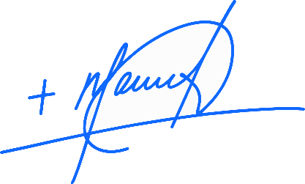
Most Reverend Manuel de Jesús Rodríguez, J.C.D.
Bishop of Palm Beach

NOTE TO PASTORS: IT IS REQUIRED THAT YOU PUBLISH THIS LETTER IN THE PARISH BULLETIN AS A HALF-PAGE OR FULL-PAGE LETTER THE WEEKEND OF JULY 4/5, 2026. THE COLLECTION WILL TAKE PLACE JULY 11/12, 2026. YOU ARE WELCOME TO READ THE LETTER TO PARISHIONERS, POST THIS LETTER ON SOCIAL MEDIA, AND ON YOUR WEBSITE, IN ADDITION TO HAVING IT PRINTED IN THE BULLETIN.

