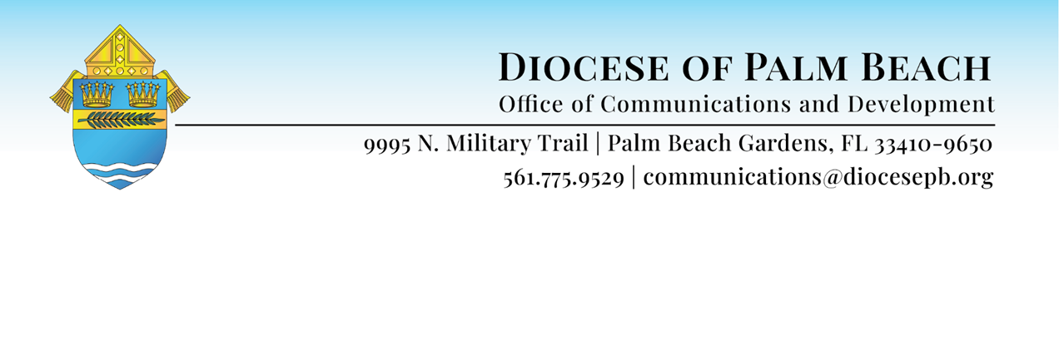

REV. MANUEL DE JESÚS RODRÍGUEZ’S REFLECTIONS ON HIS APPOITNEMNT AS BISHOP-ELECT FOR THE DIOCESE OF PALM BEACH
December 19, 2025
“My name is Father Manuel de Jesús Rodríguez. As has already been mentioned, I come from the Diocese of Brooklyn in New York. However, although my last name is “Rodríguez,” and although I was born in the Dominican Republic, I wish to clarify from the outset that I am not a cousin of Alex Rodríguez—A-Rod—even though, with all due respect to the Marlins, I must confess that I am a lifelong Yankees fan. That said, I am also on friendly terms with the Mets, since I currently reside just steps away from their stadium, which happens to be located within the territory of my parish in Corona, Queens.
The immediate story of my arrival here today began last Sunday, December 14, at approximately 4:30 in the afternoon, when—amid the usual demands of parish ministry—my cellphone began to ring. To my surprise, the screen displayed: “Apostolic Nunciature.” I found it rather unusual to receive a call from what is normally an office on a Sunday afternoon. When I answered, the caller identified himself as the Apostolic Nuncio, Cardinal Pierre, and without delay said to me: “The Holy Father has appointed you Bishop of Palm Beach.” I must confess that I only managed to hear the words “Holy Father” and “Beach.” My reaction was one of utter disbelief. I replied: “Are you certain that you are the Apostolic Nuncio? Is this perhaps some kind of artificial-intelligence prank or something of the sort?”
Cardinal Pierre, laughing kindly, assured me that it was indeed he and that I should believe him precisely because it was he. At that moment, I recognized his unmistakable French accent and realized the call was genuine. And then—I was terrified.
After accepting the assignment, I asked Cardinal Pierre for permission to contact my Bishop, the Most Reverend Robert J. Brennan, in order to catch my breath and begin to comprehend what was happening. Shortly thereafter, I received an encouraging call from Bishop Barbarito, with whom I have remained in constant contact ever since, and to whom I shall always be deeply grateful for his exquisite kindness, fraternal spirit, and pastoral accompaniment.
And here we are—seeking to respond faithfully to the call of God and of the Church, voiced through the person of the Holy Father, Pope Leo XIV. Saint John Bosco, in whose spiritual school I was formed, once said that “no effort is too great when it concerns the Church and the Pope.”
I do not bring much with me—only myself and my faith in Christ Jesus, whom I follow as my Lord and Savior, and whom I will serve all my life. For this reason, I make my own the words of Saint Peter when he once encountered a poor man, crippled and begging at the gate of the Temple in Jerusalem: “I have neither silver nor gold, but what I have I give you” (cf. Acts 3:6).
I come, however, as a soldier of the Church, determined to join you, dear members of the pilgrim Church in Palm Beach, to walk with you and support you in our shared mission of extending the Kingdom of God in this land of the Lord—through the many works, programs, and initiatives you already carry forward with such dedication, and through others that we may begin together, in response to the needs and challenges of the reality in which we live.
I wish to offer my personal recognition and highest esteem to our beloved Bishop Gerald Barbarito, who has served as Bishop of Palm Beach for more than twenty-two years. Thanks to his witness of faith, his pastoral fatherhood, his tireless dedication, and his total self-giving to the episcopal ministry in this Diocese, our local Church today enjoys peace, has achieved remarkable pastoral development, and is well prepared to continue advancing along the path of evangelization, solidarity, Christian education of our children and youth, the defense of life and human dignity, and the pursuit of an ever more just society. Thank you, dear Bishop Barbarito, for having helped this Diocesan Church accomplish so much. Your name will be remembered with profound respect and reverence in this Diocese.
I also wish to greet with deep affection my brother priests. I feel truly happy and deeply moved to share with you this great challenge entrusted to us by the Lord. From this moment forward, you may count on my friendship, my full support, my fraternal and paternal affection, and above all, my prayer for you and for the wonderful apostolic work you carry out on behalf of our people.
Un saludo muy cariñoso también a todas las familias presentes en nuestra Diócesis y a todos los hermanos y hermanas que se encuentran comprometidos en el trabajo de la Iglesia sirviendo en nuestras Parroquias como catequistas, ministros litúrgicos, servidores de los Grupos de Oración y Grupos Apostólicos (como los Cursillistas, Emaús, la Legión de María, entre otros). Dios les bendiga por todo lo que hacen en favor de la fe y del Reino de Dios.

An kè ansanm ak Vyèj Mari ki pi Sen an, Manman ak Pwotektè nou, annou avanse ak anpil antouzyasm pou nou kontinye fè prezan nan Dyosèz nou an apèl Senyè nou an pou anonse Levanjil la bay tout kreyati.
Coming from Brooklyn, I invite you to cast your gaze upon the iconic Brooklyn Bridge, which since 1869 has stood as one of New York City’s most cherished symbols. In that same spirit, I come with the sincere desire to collaborate with all of you in continuing to build bridges: bridges of love among ourselves; bridges of hope and solidarity with those most in need; bridges of accompaniment for our young people; bridges that lead us ever more deeply to the Heart of the One in whom we live and move and have our being—God, our Lord.
Thank you very much. God bless us all.”

