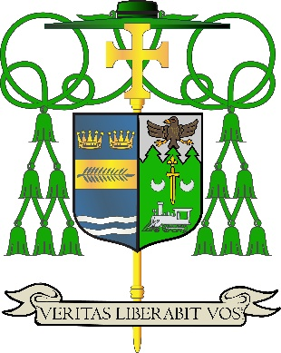
Office of
THE DIOCESAN
BISHOP

9995 North Military Trail • P.O. Box 109650
Palm Beach Gardens, Florida 33410-9650

(561) 775-9595 Fax (561) 775-7035

Diocese of Palm Beach

April 10, 2026

Dear Brothers and Sisters in Christ:
From his first appearance after his election in May 2025, Pope Leo XIV has called upon Catholics to live in peace and unity with one another within the Church and to share this invitation to peace and unity with the whole world. Throughout history, Catholics have shared the peace and unity of Christ with the world by proclaiming the Gospel and performing works of mercy that bring comfort to the poor and vulnerable.

For centuries, Catholics have expressed our unity with the pope by giving to the Peter’s Pence Collection, which supports his mission to share Christ’s message with the world. Our gifts to the Holy Father fulfill the two aims of Peter’s Pence: “1) To support the Holy Father’s mission, which extends throughout the entire world, from the proclamation of the Gospel to the promotion of integral human development, education, peace, and brotherhood among peoples: thanks also to the many activities of service carried out by the dicasteries, bodies and organs of the Holy See that assist him every day; and 2) To support the numerous charitable works in aid of people and families in difficulty, populations afflicted by natural disasters and wars, or who are in need of humanitarian assistance or support for development.”

Please prayerfully consider supporting this year’s collection as an act of hope and charity. Join our brothers and sisters in faith from around the globe to help Pope Leo XIV carry out his ministry to the Universal Church and reach out to the most marginalized in our world.

Assuring you and all those you love of my continued remembrance in the celebration of the Holy Eucharist, and commending you to the loving intercession of the Blessed Virgin Mary, Queen of the Apostles, I remain
Sincerely yours in our Lord Jesus Christ,
Most Reverend Manuel de Jesús Rodríguez, J.C.D.
Bishop of Palm Beach

NOTE TO PASTORS: IT IS REQUIRED THAT YOU PUBLISH THIS LETTER IN THE PARISH BULLETIN AS A HALF-PAGE OR FULL-PAGE LETTER THE WEEKEND OF APRIL 11/12, 2026. THE COLLECTION WILL TAKE PLACE APRIL 18/19, 2026. YOU ARE WELCOME TO READ THE LETTER TO PARISHIONERS, POST THIS LETTER ON SOCIAL MEDIA, AND ON YOUR WEBSITE IN ADDITION TO HAVING IT PRINTED IN THE BULLETIN.

