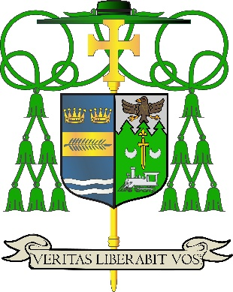

Office of
THE DIOCESAN
BISHOP

9995 North Military Trail • P.O. Box 109650
Palm Beach Gardens, Florida 33410-9650

(561) 775-9595 Fax (561) 775-7035

Diocese of Palm Beach

May 8, 2026

Dear Brothers and Sisters in Christ:

Next weekend, there will be a special collection for the Catholic Communication Campaign and Catholic University of America. These worthy causes ensure that the Gospel message is spread throughout our Diocese of Palm Beach, nation and world.

The Catholic communications portion of the collection supports national communication efforts and our interactive diocesan projects, such as the weekly Televised Catholic Mass, the Florida Catholic e-edition and printed newspaper, our active social media presence and website (www.DiocesePB.org). These digital tools help the Church inform, instruct and inspire.

A portion of the May 16/17 collection supports the United States Bishops’ university in Washington, D.C. Founded by a pontifical charter in 1887 as the national research university of the Church in the United States, Catholic University of America has served the Church and our nation for more than 130 years. Your contributions are critical to both a successful academic year and to all the important work the university does on behalf of its faithful.
Assuring you and all those you love of my continued remembrance in the celebration of the Holy Eucharist, and commending you to the loving intercession of the Blessed Virgin Mary, Queen of the Apostles, I remain

Sincerely yours in our Lord Jesus Christ,
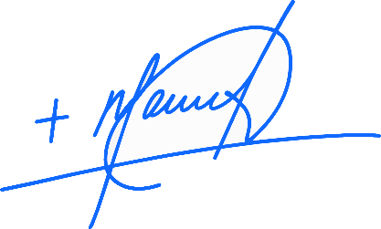
Most Reverend Manuel de Jesús Rodríguez, J.C.D.
Bishop of Palm Beach

NOTE TO PASTORS: IT IS REQUIRED THAT YOU PUBLISH THIS LETTER IN THE PARISH BULLETIN AS A HALF-PAGE OR FULL-PAGE LETTER THE WEEKEND OF MAY 9/10, 2026. THE COLLECTION WILL TAKE PLACE MAY 16/17, 2026. YOU ARE WELCOME TO READ THE LETTER TO PARISHIONERS, POST THIS LETTER ON SOCIAL MEDIA, AND ON YOUR WEBSITE, IN ADDITION TO HAVING IT PRINTED IN THE BULLETIN.

