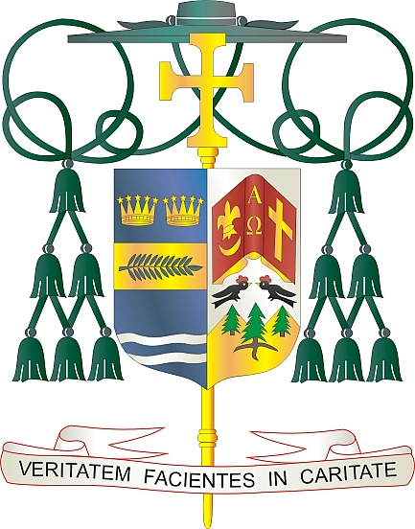
Office of
THE BISHOP

9995 North Military Trail • P.O. Box 109650
Palm Beach Gardens, Florida 33410-9650

(561) 775-9595 Fax (561) 775-7035

Diocese of Palm Beach

4 Jen 2022

Chè sè ak frè nan Kris la:

Wikenn pwochen, 11/12 jen, Dyosèz Palm Beach pral gen yon koleksyon espesyal pou 2 kòz: Misyon Nwa ak Endyen ak Misyon Home Katolik.

Koleksyon Misyon Nwa ak Endyen an sipòte twa òganizasyon diferan men ki gen rapò ant yo (Biwo Misyon Katolik Endyen yo, Komisyon Misyon Katolik yo ak Komisyon Misyon Nèg-Ameriken Katolik yo), yo chak avèk pwòp objektif ak istwa pa yo, men yo tout ap chèche akonpli menm koz la. Fonde pa evèk Katolik Ozetazini, chak òganizasyon kolabore ak kominote dyosezen lokal la pou gaye Bòn Nouvèl Jezikri a epi reponn a bezwen reyèl ak ijans sou teren an.
Pòsyon Misyon Home Katolik nan koleksyon an se yon apèl anyèl atravè Konferans Evèk Katolik Ameriken an ki sipòte dyosèz ak epachi nan Etazini ak teritwa li yo ki pa kapab soutni ministè debaz yo san èd finansye ki sòti deyò.

Lajan yo sipòte inisyativ pou evanjelizasyon, fòmasyon lafwa, lavi ak diyite moun, ranfòse maryaj ak fanmiy yo, vokasyon prèt ak relijye, ministè pou popilasyon panyòl, Ameriken natif natal ak popilasyon endijèn nan Alaska, ak asistans pou dyosèz ak pawas ki gen bezwen administratif, tankou kominikasyon ak planifikasyon pastoral.

Avèk rekonesans pou jenewozite w ak tout volonte lapriyè m, se mwen menm

Sensèman nan Kris la,

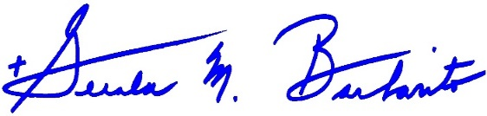
Monsenyè Gerald M. Barbarito
Evèk Palm Beach

NÒT POU PASTÈ YO: LI OBLIGATWA POU OU PILIYE LÈT SA A NAN BILTEN PAWAS LA NAN YON MWATYE PAJ OSWA LÈT LA NAN YON PAJ ANTYE NAN WIKENN 4/5 JEN 2022. KOLEKSYON AN PRAL FÈT 11/12 JEN 2022. LI PA YON PROBLEM POU OU KA LI LÈT POU PAWASYEN YO, POSTE L SOU REZO SOSYAL AK SOU WEBSITE OU A, ANPLIS AK ENPRIME L NAN BILTEN AN.

