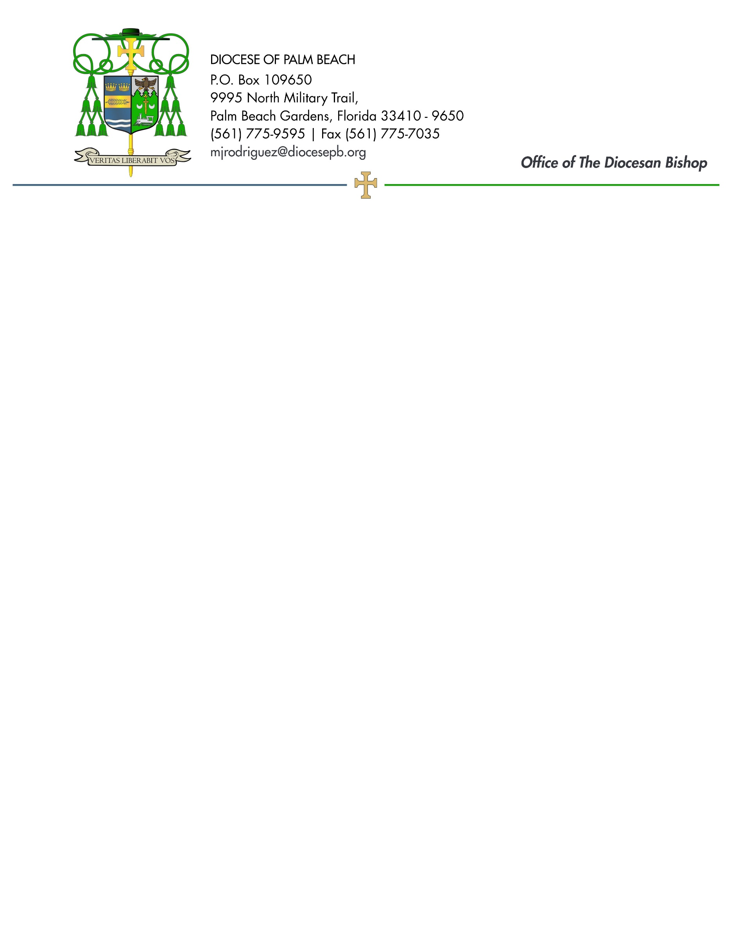
October 30, 2026

Dear Sisters and Brothers in Christ:

Next weekend, November 7/8, funds will be collected for a national initiative that supports activities reflecting Catholic moral and social teaching on human life and dignity. The Catholic Campaign for Human Development is a sign of how the Church lives out the call from Scripture and Tradition to give special concern and priority to the needs of those who are living in poverty. Your support for this collection brings change to communities across the country and empowers the poor to transform their neighborhoods into reflections of the Kingdom of God.

For more than 50 years, CCHD has worked with dioceses and their bishops to award grants to local, low-income groups working to address the causes of poverty. By helping the poor to participate in the decisions and actions that affect their lives, CCHD offers a hand up, not a handout, helping people and communities overcome prejudice and build bridges of solidarity.

When you give to this collection, you make an impact nationally and at home, because 25% of your contribution stays within our own Diocese through Catholic Charities. This way you help your community build on this legacy of success while also helping regions across the United States.

With more than 250,000 individuals in our Diocese and 34.5 million nationwide living in poverty, your support of this collection can help change the lives of “the least of these” (Matthew 25). Your financial help for CCHD is an act of solidarity with our struggling brothers and sisters. Thank you for considering support for this worthwhile cause.

Assuring you and all those you love of my continued remembrance in the celebration of the Holy Eucharist, and commending you to the loving intercession of the Blessed Virgin Mary, Queen of the Apostles, I remain

Sincerely yours in our Lord Jesus Christ,
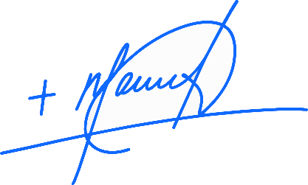
Most Reverend Manuel de Jesús Rodríguez, J.C.D.
Bishop of Palm Beach

NOTE TO PASTORS: IT IS REQUIRED THAT YOU PUBLISH THIS LETTER IN THE PARISH BULLETIN AS A HALF-PAGE OR FULL-PAGE LETTER THE WEEKEND OF OCTOBER 31-NOVEMBER 1. THE COLLECTION WILL TAKE PLACE NOVEMBER 7/8, 2026. YOU ARE WELCOME TO READ THE LETTER TO PARISHIONERS, POST THIS LETTER ON SOCIAL MEDIA, AND ON YOUR WEBSITE IN ADDITION TO HAVING IT PRINTED IN THE BULLETIN.

