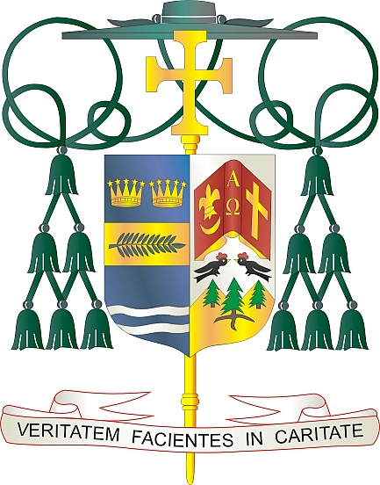

Office of  
THE BISHOP

9995 North Military Trail • P.O. Box 109650

Palm Beach Gardens, Florida 33410-9650

(561) 775-9595 Fax (561) 775-7035

## Diocese of Palm Beach

April 15, 2023

Dear Brothers and Sisters in Christ:

Next weekend, April 22 and 23, 2023, our Diocese will participate in the annual Peter’s Pence Collection. This collection supports the Universal Church and the work of the Holy See, including helping Pope Francis to carry out his charitable works. These works benefit our brothers and sisters on the margins of society, including victims of war, oppression, and disasters.

Your contribution to the Peter’s Pence collection helps fund not only all the activities of the dicasteries of the Roman Curia that assist the Pope in the exercise of his ministry but also a number of solidarity projects that aid those most in need. Please prayerfully consider supporting this year’s collection as an act of mercy and charity.

By contributing to Peter’s Pence, we can together support the Pope’s mission through the activities of the Holy See and the initiatives of solidarity in favor of the most vulnerable, to whom the Church’s attention has been traditionally directed.

With gratitude for your continued generosity and every prayerful wish, I am

Sincerely yours in Christ,

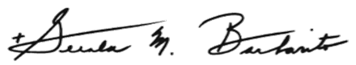

Most Reverend Gerald M. Barbarito  
 Bishop of Palm Beach

**NOTE TO PASTORS: IT IS REQUIRED THAT YOU PUBLISH THIS LETTER IN THE PARISH BULLETIN AS A HALF-PAGE OR FULL-PAGE LETTER THE WEEKEND OF APRIL 15/16, 2023. THE COLLECTION WILL TAKE PLACE APRIL 22/23, 2023. YOU ARE WELCOME TO READ THE LETTER TO PARISHIONERS, POST THIS LETTER ON SOCIAL MEDIA AND ON YOUR WEBSITE, IN ADDITION TO HAVING IT PRINTED IN THE BULLETIN.**