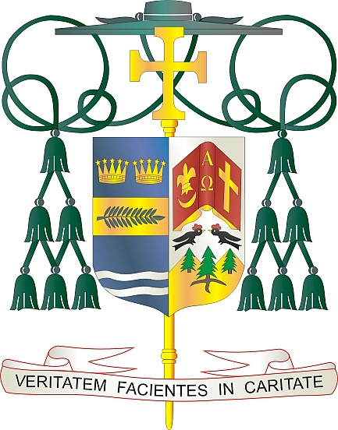

Office of  
THE BISHOP

9995 North Military Trail • P.O. Box 109650

Palm Beach Gardens, Florida 33410-9650

(561) 775-9595 Fax (561) 775-7035

## Diocese of Palm Beach

October 31, 2025

Dear Brothers and Sisters in Christ:

Next weekend, November 8/9, a collection for the Catholic Campaign for Human Development will be taken up in the Diocese of Palm Beach. Your support for this collection brings change to communities across the country and empowers those living in poverty to transform their communities into reflections of the Kingdom of God.

For more than 50 years, CCHD has helped low-income people address the root causes of poverty and injustice, not by giving “one-size-fits-all” handouts, but by funding local organizations that empower the impoverished to make positive impacts in their own communities. This grassroots model allows people to use their experiences and knowledge of their communities to build coalitions of faith leaders, local businesses and other neighbors who work together to find solutions that benefit everyone.

When you give to the CCHD collection, you make an impact nationally and at home, because 25% of your contribution stays within our own Diocese through Catholic Charities. This way you help your community build on this legacy of success while also helping communities across the nation.

With more than 250,000 individuals in our Diocese and nearly 37 million nationwide living in poverty, your support of this collection can help create meaningful change. Your spiritual and financial support of CCHD is an act of solidarity with our struggling brothers and sisters. Thank you for considering your support of this worthwhile effort.

With gratitude for your continued generosity and with every prayerful wish, I am

Sincerely yours in Christ,

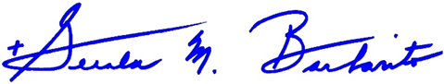

Most Reverend Gerald M. Barbarito  
 Bishop of Palm Beach

**NOTE TO PASTORS: IT IS REQUIRED THAT YOU PUBLISH THIS LETTER IN THE PARISH BULLETIN AS A HALF-PAGE OR FULL-PAGE LETTER THE WEEKEND OF NOVEMBER 1/2. THE COLLECTION WILL TAKE PLACE NOVEMBER 8/9, 2025. YOU ARE WELCOME TO READ THE LETTER TO PARISHIONERS, POST THIS LETTER ON SOCIAL MEDIA, AND ON YOUR WEBSITE IN ADDITION TO HAVING IT PRINTED IN THE BULLETIN.**