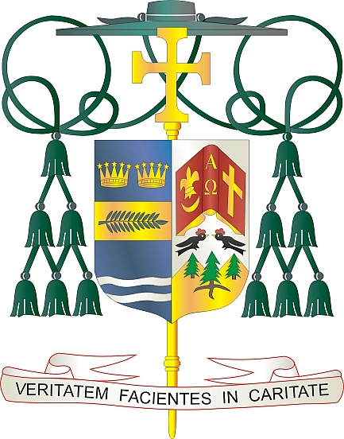
Office of
THE BISHOP

9995 North Military Trail • P.O. Box 109650
Palm Beach Gardens, Florida 33410-9650

(561) 775-9595 Fax (561) 775-7035

Diocese of Palm Beach

July 31, 2021

Dear Brothers and Sisters in Christ:

On August 7 and 8, our Diocese will have a second collection to benefit two areas of need: the Church in Latin America and the Solidarity Fund for the Church in Africa. The funds collected next weekend will be split between these two important areas and allow us to join in unity to support these communities outside of the United States.

For more than 50 years, the collection for the Church in Latin America has been an expression of unity and solidarity between Catholics in the United States and those in Latin America and the Caribbean. Catholics like you, from across the United States, have supported the formation of priests and religious, the training of catechists and other pastoral ministers, the education of children and young people, and relief efforts in the wake of natural disasters in this area. Next weekend’s collection supports many pastoral projects that benefit the faithful in Latin America and the Caribbean, plus it allows you to stand in closer unity with refugees and those serving them.

The Solidarity Fund for the Church of Africa supports those who still lack access to basic resources and pastoral care. Your donation specifically supports pastoral projects to build the capacity of the Church and foster lasting peace and reconciliation in a continent often marked by division and tension. As the Church in Africa grows, the pastoral needs of the people also increase. From the formation of clergy to communications programs that bring the Gospel to remote territories to youth ministries that engage the next generation of disciples, the Church’s needs are wide-ranging. The Solidarity Fund is an opportunity for our diocese to stand with the people of Africa.

Because of your generosity, our brothers and sisters in Latin America, the Caribbean and Africa will have the opportunity to grow in faith and answer the call of God. Through your financial gifts, as well as your prayerful remembrance, we join as one family of faith in making the Gospel of Jesus Christ known around the world.

With gratitude for your continued generosity and with every prayerful wish, I am

Sincerely yours in Christ,
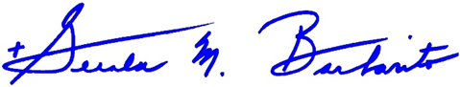

Most Reverend Gerald M. Barbarito
Bishop of Palm Beach

NOTE TO PASTORS: IT IS REQUIRED THAT YOU PUBLISH THIS LETTER IN THE PARISH BULLETIN AS A HALF PAGE OR FULL-PAGE LETTER THE WEEKEND OF JULY 31/AUGUST 1, 2021. THE COLLECTION WILL TAKE PLACE AUGUST 7/8, 2021. YOU ARE WELCOME TO READ THE LETTER TO PARISHIONERS, POST THIS LETTER ON SOCIAL MEDIA, AND ON YOUR WEBSITE IN ADDITION TO HAVING IT PRINTED IN THE BULLETIN.

