Diocese of Palm Beach
9995 North Military Trail • P.O. Box 109650
Palm Beach Gardens, Florida 33410-9650

(561) 775-9595 Fax (561) 775-7035
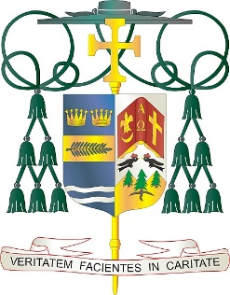
Office of
THE BISHOP

December 19, 2025

Bishop Barbarito’s Statement of the appointment of the
new Shepherd for the Diocese of Palm Beach

I am grateful to our Holy Father, Pope Leo XIV for his prayerful discernment in appointing a new Shepherd for the Diocese of Palm Beach in Bishop-elect Manuel de Jesus Rodriguez, a priest ordained for the Archdiocese of Santo Domingo in 2004, who has ministered as an incardinated priest of the Diocese of Brooklyn since 2012, his current assignment being the pastor of Our Lady of Sorrows, Corona, Queens. He is a young (50 years of age), enthusiastic and pastoral priest, who is described as a “priest who walks with the people.” With all of you, I welcome him to our Diocesan family, which will be greatly blessed by his ministry, and I very much look forward to getting to know him as in just a few days he has shown himself to be a deeply spiritual and exceptional priest.

Bishop Rodriguez is coming to a wonderful Diocese of diverse background and vibrant faith. It has been a great joy for me to have ministered here for almost twenty-three years. In accord with canon law, I submitted my resignation to the Pope almost one year ago on my seventy-fifth birthday, and, with the appointment of Bishop-elect Rodriguez, it is now formally accepted. However, while I am also from Brooklyn, I will remain here in Palm Beach, which has become my home as it has for so many others from New York. I am very pleased when I am told that my Brooklyn accent has become even more pronounced since I have been in Palm Beach. I thank all of you for being the wonderful family of faith, hope, and love that you are. I look forward to my continued home here assisting the new Bishop pastorally, in any manner I can. I also look forward to more time for prayer and study.

As of today, I am officially the Bishop Emeritus of the Diocese of Palm Beach and also appointed its Apostolic Administrator until the day of Bishop-elect Rodriguez’s ordination which has not yet been set.

It is my great privilege to present to you Bishop-elect Manuel de Jesus Rodriguez.

###

