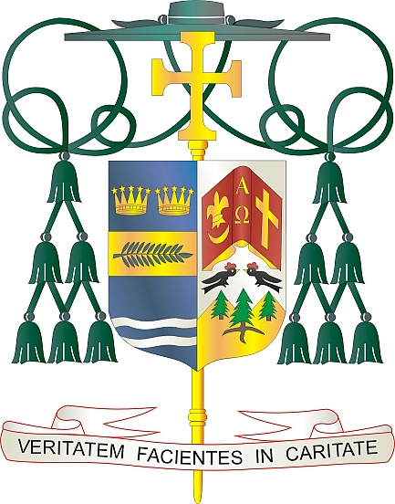
Office of
THE BISHOP

9995 North Military Trail • P.O. Box 109650
Palm Beach Gardens, Florida 33410-9650

(561) 775-9595 Fax (561) 775-7035

Diocese of Palm Beach

May 1, 2021

Dear Sisters and Brothers in Christ:

Next weekend, the diocese will have a special collection for the Catholic Communication Campaign (CCC). Half of the CCC collection will fund the national communication efforts of the U.S. Bishops. The remainder of the collection funds our local diocesan communications projects such as the popular Televised Catholic Mass, the recently updated Florida Catholic Media initiative, the diocese’s vibrant social media sites and website, which is updated daily.

Our special collection on May 8/9, also supports Catholic University of America in Washington, D.C., the national university of the Catholic Church. As the only institution of higher education in the U.S. founded by our bishops and chartered by the Vatican, the university educates clergy, religious, and lay faithful from across the nation.

As Pope Francis said in his statement for the 2021 World Communications Day, “The challenge that waits us, then, is to communicate by encountering people, where they are and as they are.” Because of your support of the CCC and Catholic University collections, millions of faithful will have the opportunity to deepen their faith through media resources and Catholic education.

With gratitude for your continued generosity and every prayerful wish, I am

Sincerely yours in Christ,
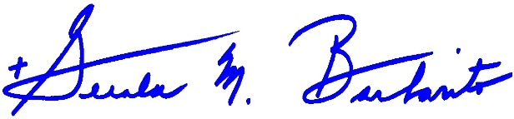
Most Reverend Gerald M. Barbarito
Bishop of Palm Beach

NOTE TO PASTORS: IT IS REQUIRED THAT YOU PUBLISH THIS LETTER IN THE PARISH BULLETIN AS A HALF PAGE OR FULL-PAGE LETTER THE WEEKEND OF MAY 1/2, 2021. THE COLLECTION WILL TAKE PLACE MAY8/9, 2021. YOU ARE WELCOME TO READ THE LETTER TO PARISHIONERS, POST THIS LETTER ON SOCIAL MEDIA, AND ON YOUR WEBSITE IN ADDITION TO HAVING IT PRINTED IN THE BULLETIN.

