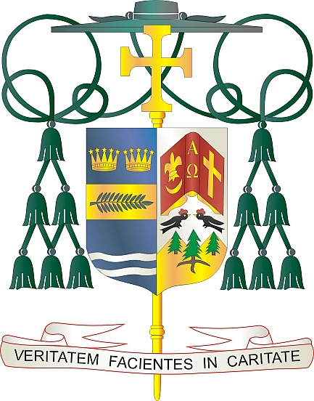
Office of
THE BISHOP

9995 North Military Trail • P.O. Box 109650
Palm Beach Gardens, Florida 33410-9650

(561) 775-9595 Fax (561) 775-7035

Diocese of Palm Beach

May 6, 2022

Dear Sisters and Brothers in Christ:

Next weekend, the Diocese will have a special collection for the Catholic Communication Campaign. Half of the CCC collection will fund the national communication efforts of the United States Bishops. The remainder of the collection funds our interactive diocesan communications projects: such as the popular Televised Catholic Mass, the online Florida Catholic e-edition, the Diocese’s lively social media presence and website (DiocesePB.org).

The special collection on May 14/15 also supports Catholic University of America, the United States Bishops’ national university in Washington, D.C. Established in 1887, it is the only institution of higher learning in the United States founded by our bishops and chartered by the Vatican.

In his message for this year’s 56th World Communications Day, Pope Francis refers to the essential role of listening in effective communication: “The Lord explicitly calls the human person to a covenant of love, so that they can fully become what they are: the image and likeness of God in his capacity to listen, to welcome, to give space to others.” In our communication efforts, we strive to embody this ideal.

With gratitude for your continued generosity and every prayerful wish, I am

Sincerely yours in Christ,
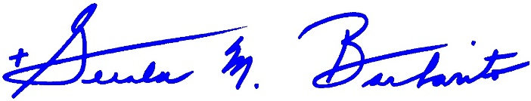

Most Reverend Gerald M. Barbarito
Bishop of Palm Beach

NOTE TO PASTORS: IT IS REQUIRED THAT YOU PUBLISH THIS LETTER IN THE PARISH BULLETIN AS A HALF PAGE OR FULL-PAGE LETTER THE WEEKEND OF MAY 7/8, 2022. THE COLLECTION WILL TAKE PLACE MAY 14/15, 2022. YOU ARE WELCOME TO READ THE LETTER TO PARISHIONERS, POST THE LETTER ON SOCIAL MEDIA, AND ON YOUR WEBSITE, IN ADDITION TO HAVING IT PRINTED IN THE BULLETIN.

