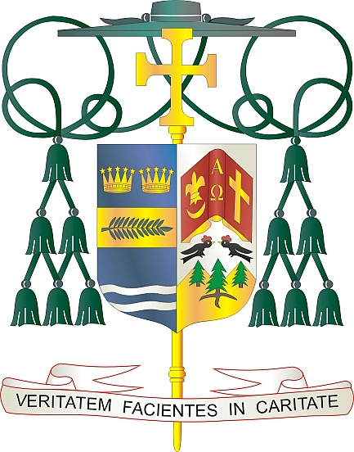
Office of
THE BISHOP

9995 North Military Trail • P.O. Box 109650
Palm Beach Gardens, Florida 33410-9650

(561) 775-9595 Fax (561) 775-7035

Diocese of Palm Beach

October 2, 2021

Dear Sisters and Brothers in Christ:

Next weekend, the parishes in our diocese will participate in a second collection for World Mission Sunday, observed on October 24, 2021. World Mission Sunday is an annual commemoration of those who live the Gospel mandate to go out to all the world and announce the Good News. The collection supports more than a thousand local churches in Asia and Africia, the Pacific Islands, and parts of Latin America and Europe.

Pope Francis’ message for World Mission Sunday this year reflects the theme: “We cannot but speak about what we have seen and heard” (Acts 4:20). He reminds us that, “as Christians, we cannot keep the Lord to ourselves,” as we “recall with gratitude all those men and women who by their testimony of life help us to renew our baptismal commitment to be generous and joyful apostles of the Gospel.”

By supporting this collection, we support the missionaries who minister in some of the most vulnerable communities around the world. May we all join with generous hearts and souls in support of this labor of love.

Thank you for your commitment to the faith and your prayers for World Mission Sunday. May God bless you and your families with every grace and peace and may our Blessed Mother always intercede for you.

With gratitude for your continued generosity and every prayerful wish, I am

Sincerely yours in Christ,

Most Reverend Gerald M. Barbarito
Bishop of Palm Beach

NOTE: IT IS REQUIRED THAT YOU PUBLISH THIS LETTER IN THE PARISH BULLETIN AS A HALF PAGE OR FULL-PAGE LETTER THE WEEKEND OF OCTOBER 2/3, 2021. THE COLLECTION WILL TAKE PLACE OCTOBER 9/10, 2021. YOU ARE WELCOME TO READ THE LETTER TO PARISHIONERS, POST THIS LETTER ON SOCIAL MEDIA, AND ON YOUR WEBSITE IN ADDITION TO HAVING IT PRINTED IN THE BULLETIN.

